**Zero Trust Identity, Governance & Operations Implementation**

**1. Project Overview**

This project demonstrates the design, implementation, and administration of a **Zero Trust–aligned Azure and Microsoft 365 environment** using an **Azure Student subscription**.

The project focuses on **administrator-level responsibilities**, including identity security, access control, governance enforcement, monitoring, cost control, and incident readiness.  
Rather than relying solely on portal-based configuration, the project emphasizes **automation using PowerShell and Infrastructure as Code (Bicep)** to reflect real-world enterprise cloud administration practices.

Where platform or licensing limitations exist in a student tenant, solutions are **designed, documented, and justified**, mirroring how professional administrators operate in constrained environments.

**2. Background & Motivation**

Modern cloud environments are identity-centric and continuously targeted by security threats. Traditional perimeter-based security models are no longer sufficient.  
**Zero Trust** assumes no implicit trust and requires:

* Strong identity verification
* Least-privilege access
* Continuous monitoring
* Governance and compliance enforcement

This project was created to simulate how a cloud administrator would **secure, govern, and operate an Azure environment** in an enterprise context, even when limited to a student subscription.

Automation through PowerShell and Bicep is used wherever possible to demonstrate:

* Repeatability
* Auditability
* Operational maturity

**3. Project Objectives**

The primary objectives of this project are to:

* Secure identities using **Azure Entra ID**, MFA, and Conditional Access
* Enforce **least-privilege access** using Azure Role-Based Access Control (RBAC)
* Apply governance controls using **Azure Policy**
* Monitor security and operational events using **Azure Monitor and logs**
* Implement **cost governance** and budget controls
* Prepare **incident response procedures and operational documentation**
* Demonstrate **Infrastructure as Code (Bicep)** and **PowerShell automation** skills

**4. Zero Trust Principles Applied**

This project aligns with core Zero Trust principles:

* **Verify explicitly**: MFA and Conditional Access for all users
* **Use least privilege**: Minimal RBAC role assignments and custom roles
* **Assume breach**: Logging, monitoring, and alerting are enabled
* **Continuous governance**: Azure Policy enforces compliance

**5. High-Level Architecture**

**Logical Flow**

Users & Devices  
↓  
Azure Entra ID  
(MFA, Conditional Access, Identity Protection)  
↓  
Azure RBAC  
(Least-Privilege Role Assignments)  
↓  
Azure Resources  
(Resource Groups governed by Azure Policy)  
↓  
Monitoring & Alerts  
(Azure Activity Logs, Sign-in Logs)  
↓  
Incident Response & Operations

This architecture ensures that **identity is the control plane** for all access and operations.

**6. Project Scope & Tools**

**Azure Services Used**

* Azure Entra ID (Azure AD)
* Azure Role-Based Access Control (RBAC)
* Azure Policy
* Azure Monitor
* Azure Cost Management
* Azure Resource Manager (ARM)

**7. Implementation Tasks (Execution Order)**

**Phase 1: Identity & Access Management (Azure Entra ID)**

**Tasks**

* Create users and security groups using PowerShell
* Implement MFA using Conditional Access
* Block legacy authentication
* Configure sign-in security settings
* Design and document break-glass access accounts

**Skills Demonstrated**

* Identity lifecycle management
* Zero Trust enforcement
* Risk-based access control

**Phase 2: Role-Based Access Control (RBAC)**

**Tasks**

* Assign built-in Azure roles using least privilege
* Create a custom RBAC role using JSON
* Assign roles at:
  + Subscription level
  + Resource Group level
* Audit and document role assignments

**Skills Demonstrated**

* Permission modeling
* Separation of duties
* Access auditing

**Phase 3: Governance & Resource Control (Azure Policy)**

**Tasks**

* Enforce mandatory resource tags
* Restrict resource deployment locations
* Assign policies at the subscription scope
* Review compliance and remediation options

**Skills Demonstrated**

* Cloud governance
* Policy enforcement
* Compliance management

**Phase 4: Resource Organization & Cost Management**

**Tasks**

* Organize resources using standardized Resource Groups
* Configure monthly cost budgets
* Set budget alerts
* Identify cost optimization opportunities

**Skills Demonstrated**

* Cost governance
* Resource lifecycle management

**Phase 5: Monitoring, Logging & Alerts**

**Tasks**

* Enable and review Azure Activity Logs
* Review Azure Entra ID sign-in logs
* Create alerts for:
  + Failed sign-in attempts
  + Role assignment changes
* Configure email-based notifications

**Skills Demonstrated**

* Operational monitoring
* Security awareness
* Alert handling

**Phase 6: Incident Response & Operational Readiness**

**Tasks**

* Design incident response procedures for:
  + Account compromise
  + Unauthorized access attempts
* Document step-by-step response actions
* Create an administrator operational checklist

**Skills Demonstrated**

* Incident handling
* Operational maturity
* Process documentation

Paste Screenshots…

**Phase 1: Identity & Access Management (Azure Entra ID)**

**Tasks**

* Create users and security groups using PowerShell
* Implement MFA using Conditional Access
* Block legacy authentication
* Configure sign-in security settings
* Design and document break-glass access accounts

**Brief Explanation:** Set up Microsoft 365 and Azure tenant from scratch. Created admin, standard, and break-glass accounts. Disabled security defaults and enforced Conditional Access requiring MFA for all users except break-glass. Registered users for MFA and validated access behavior using sign-in logs.

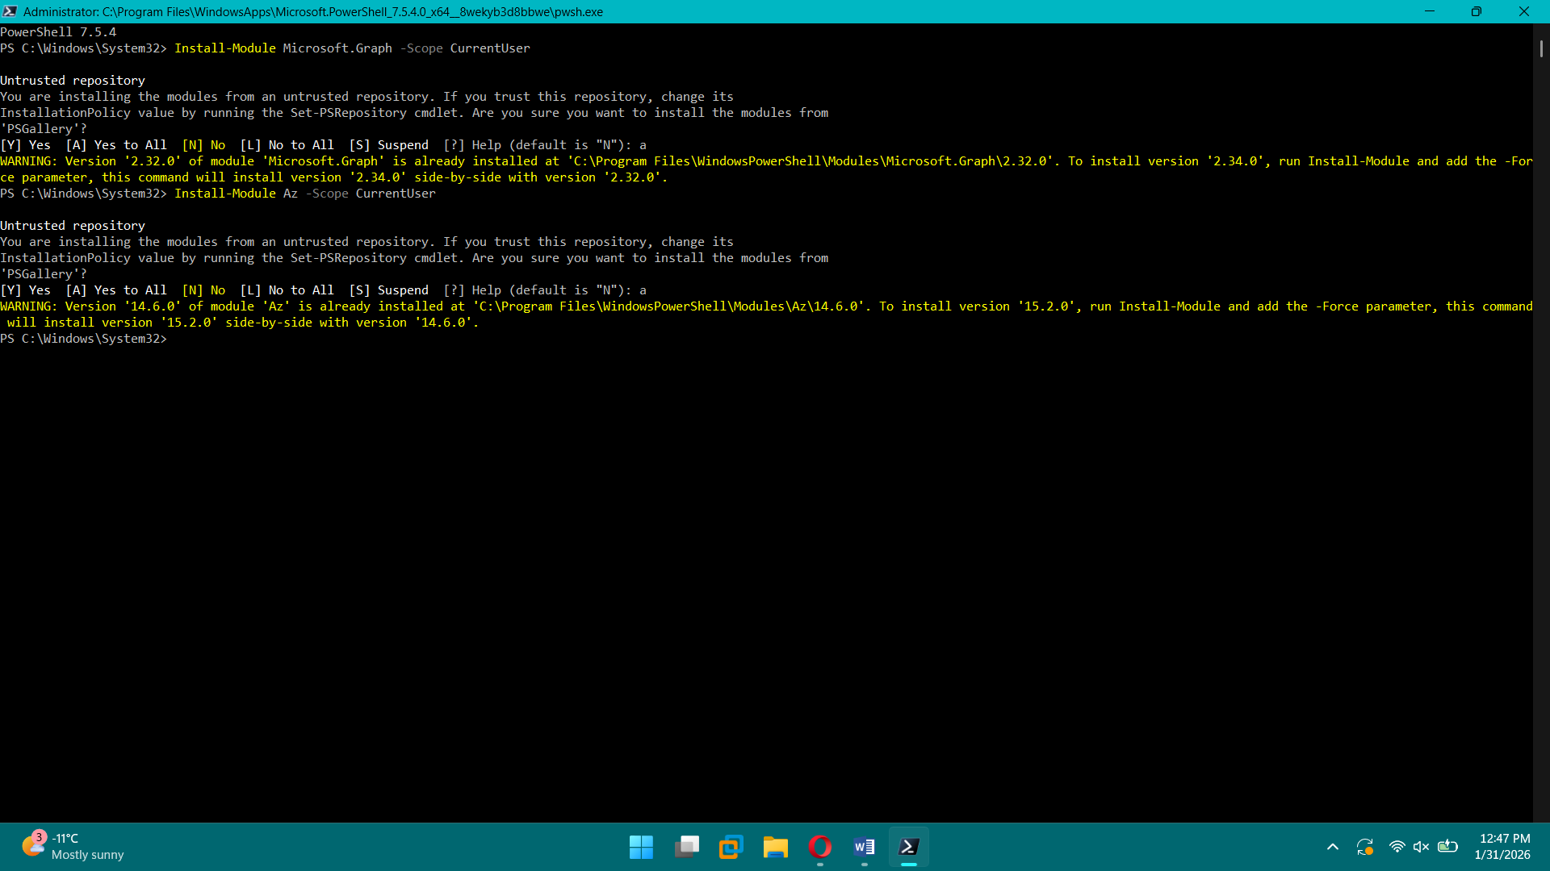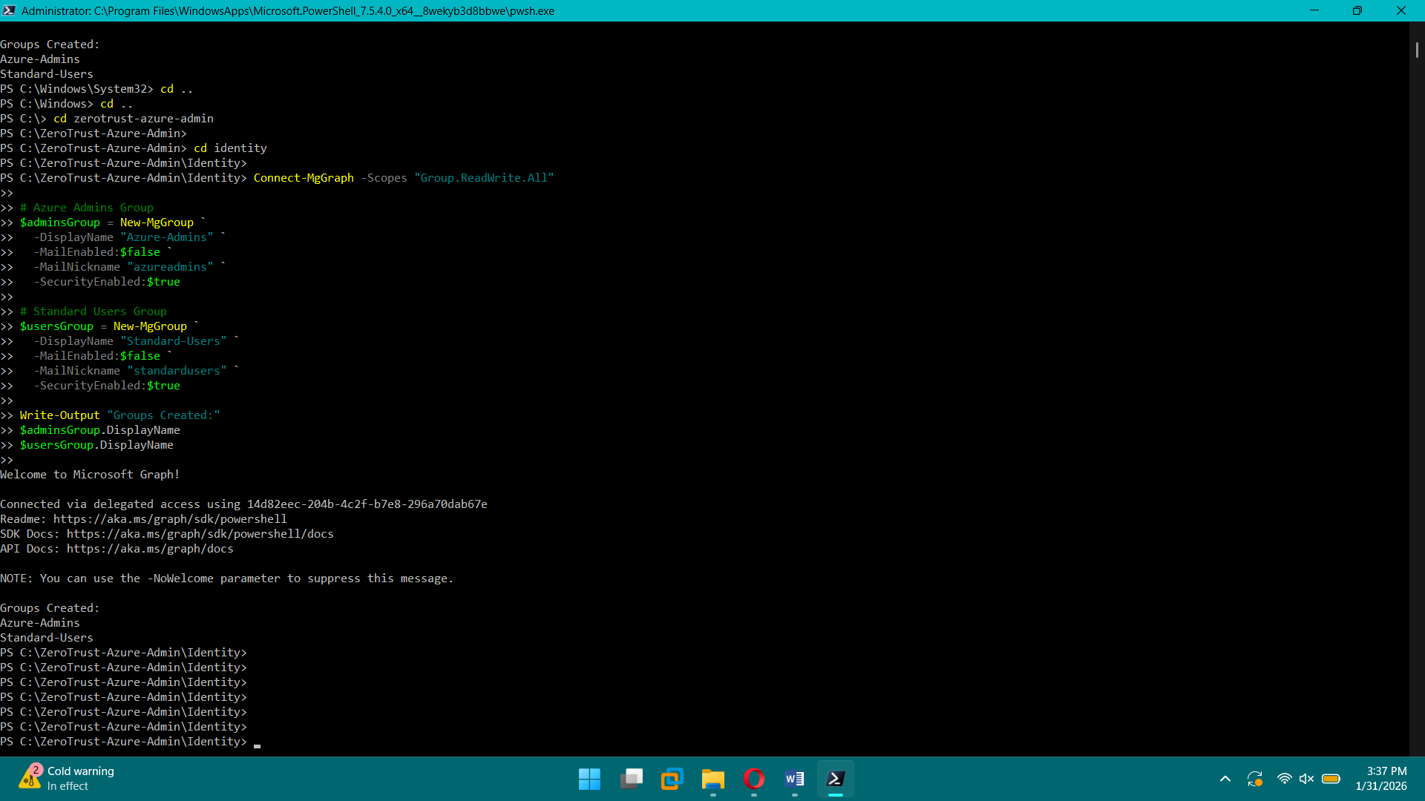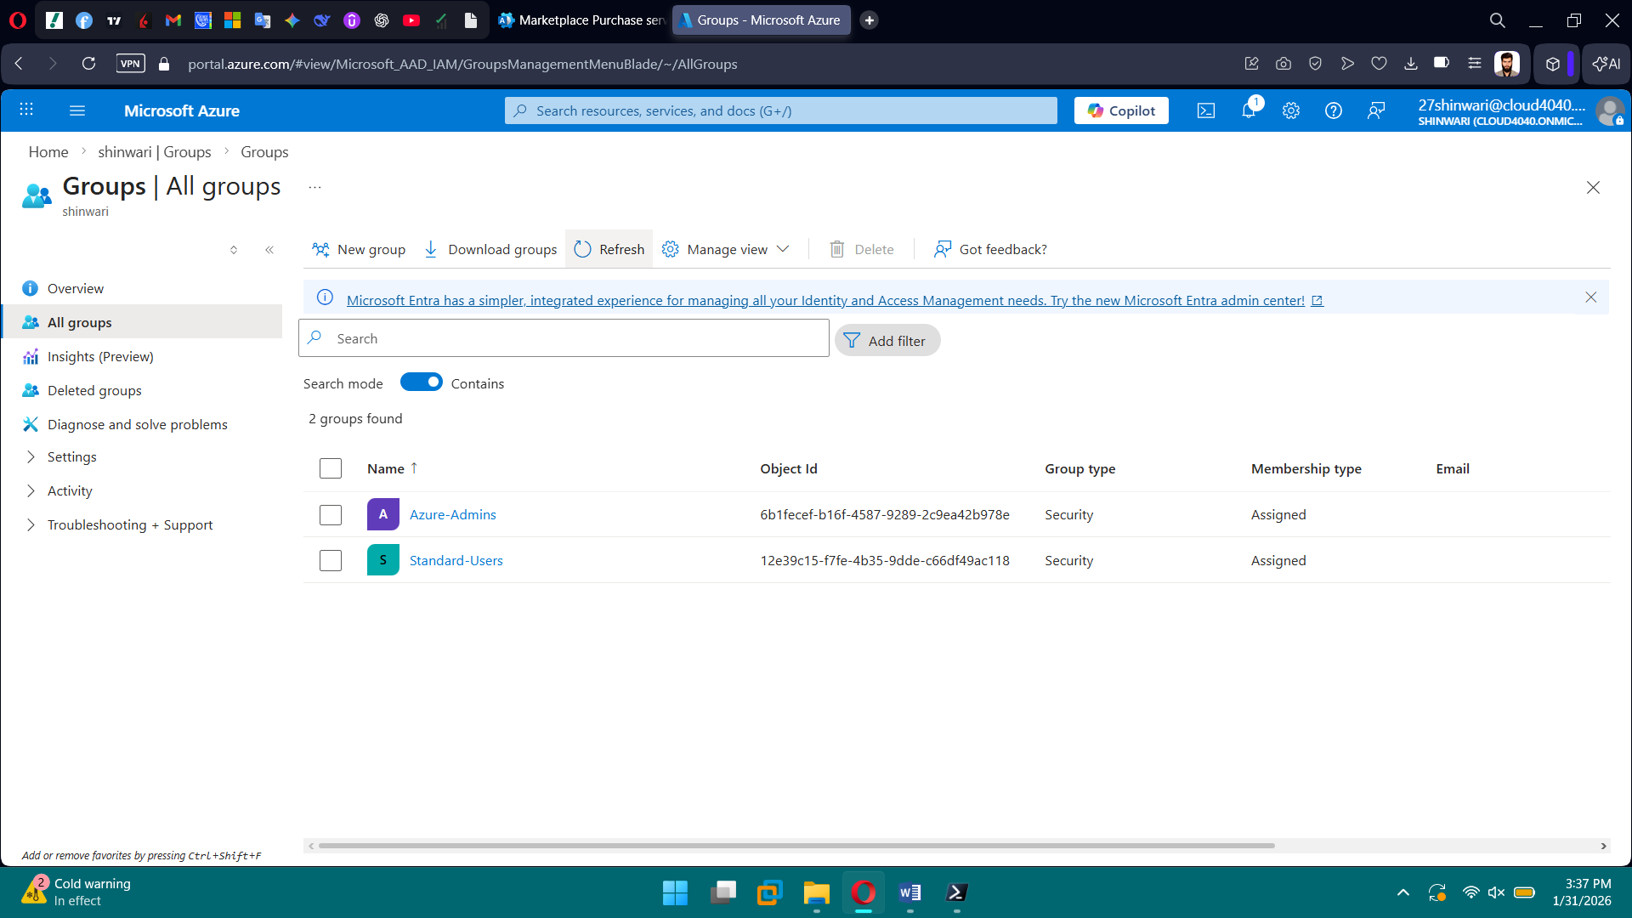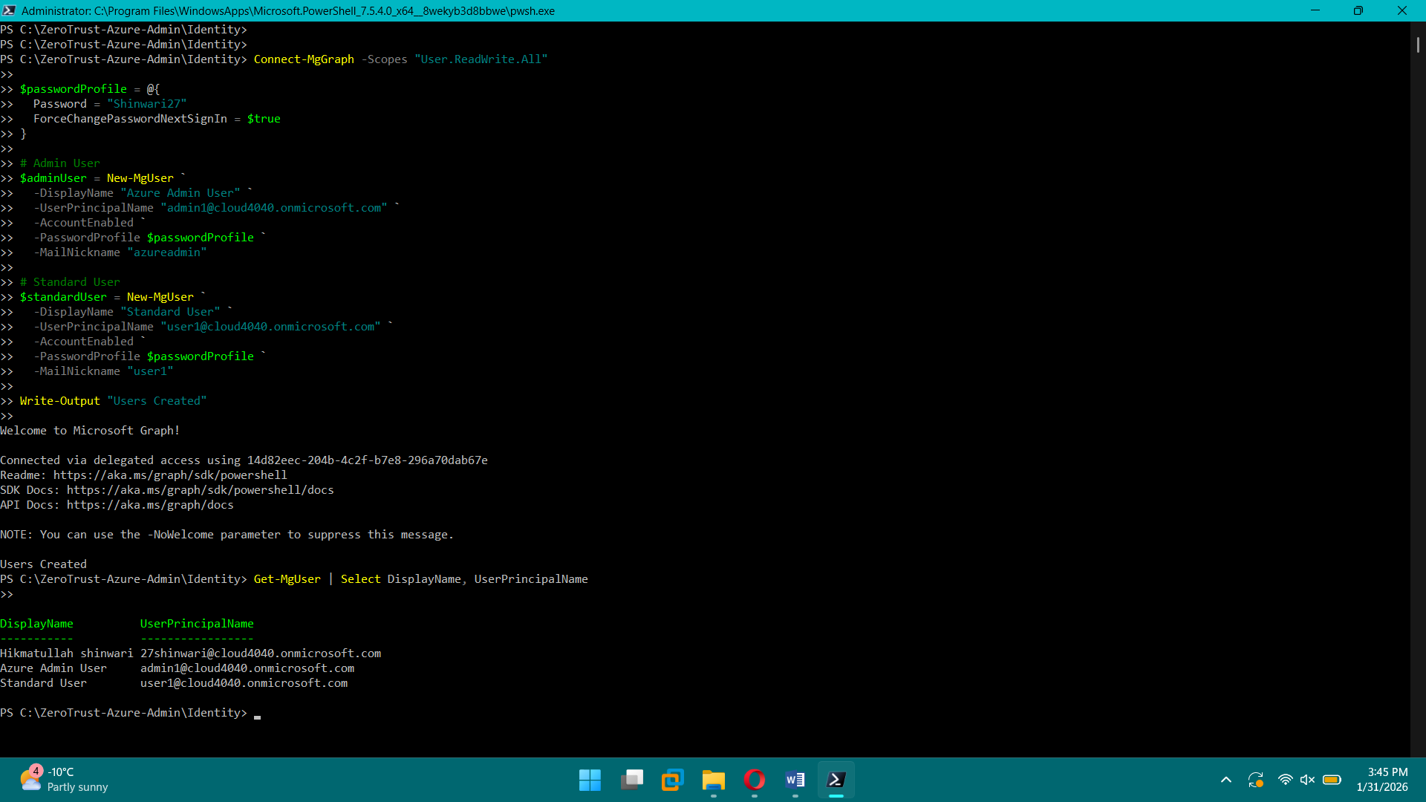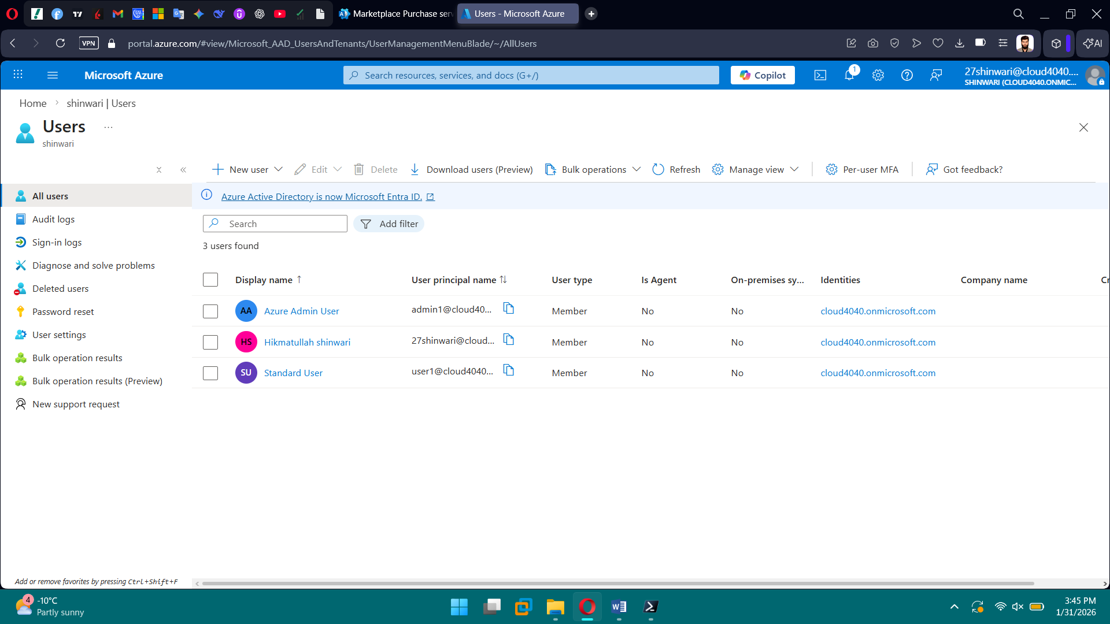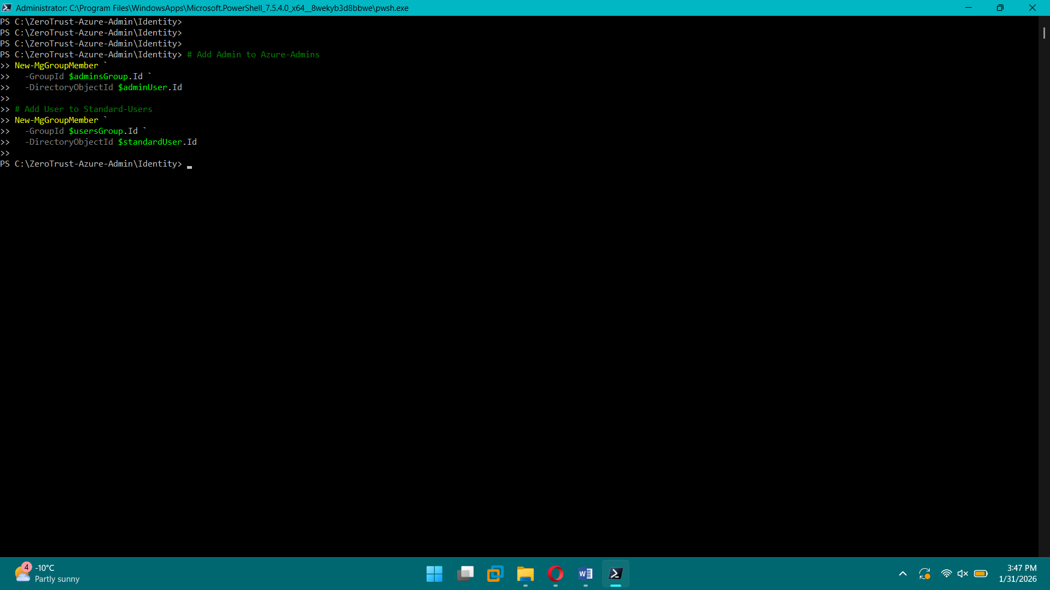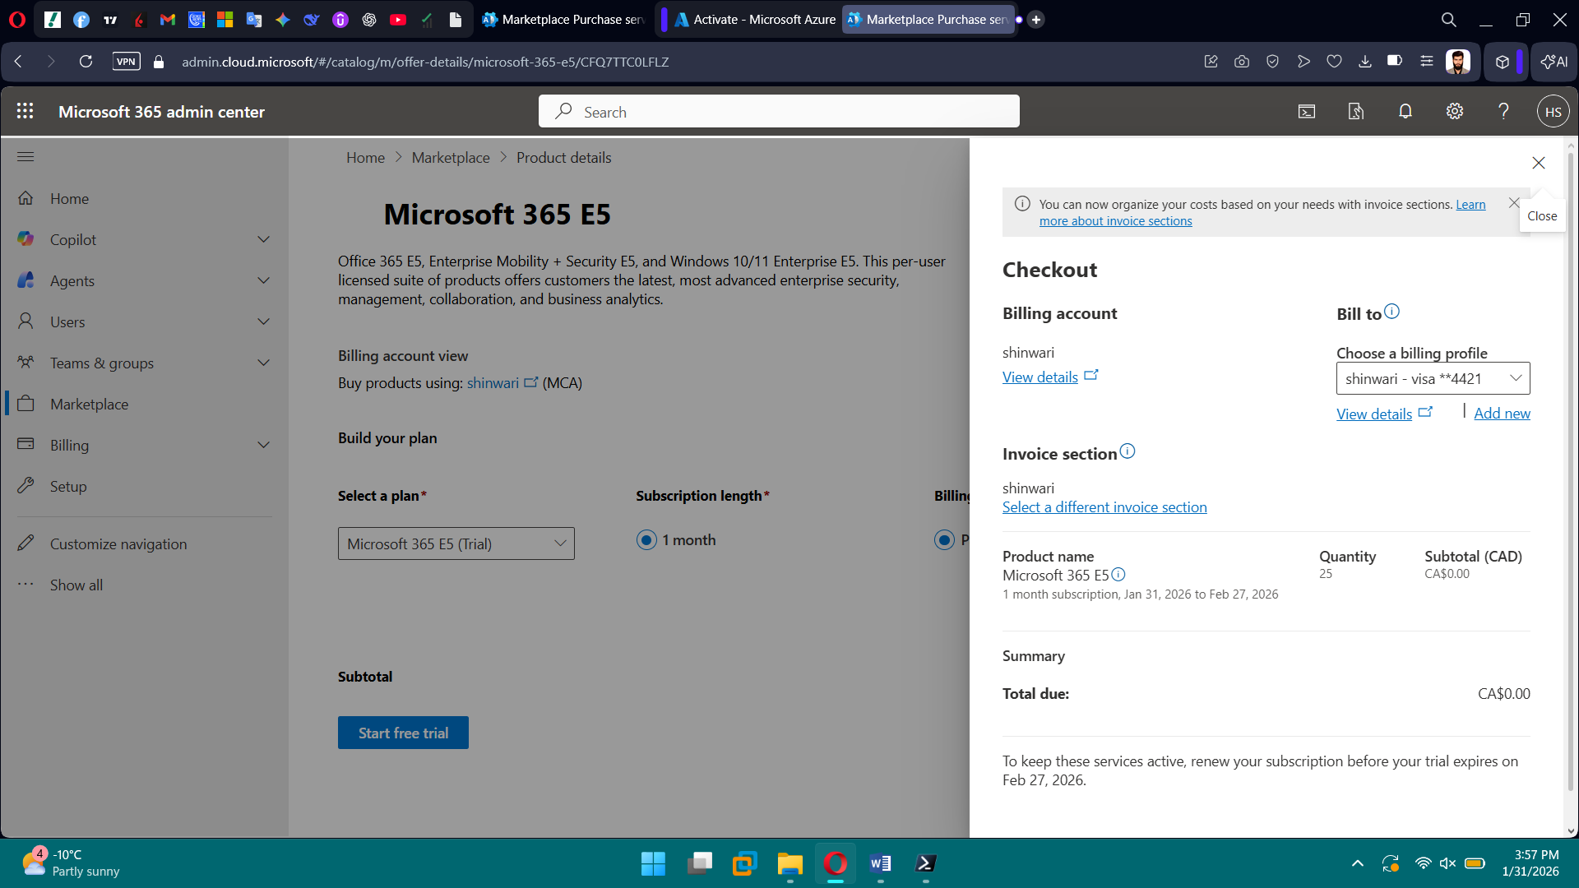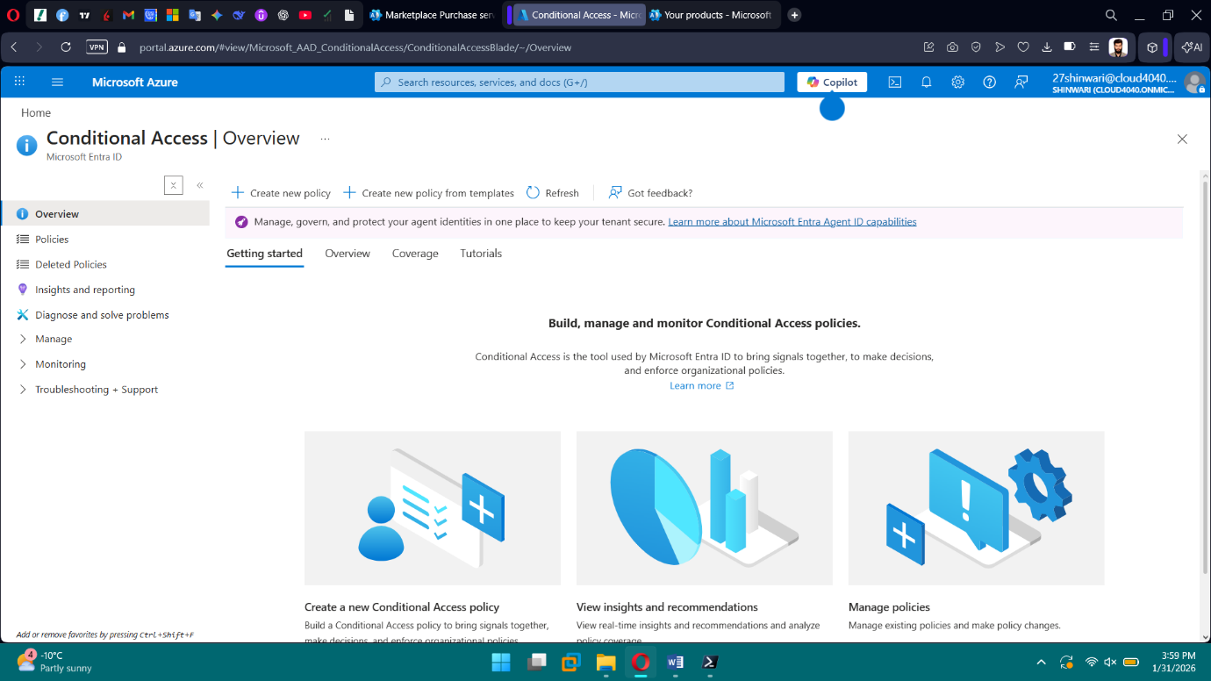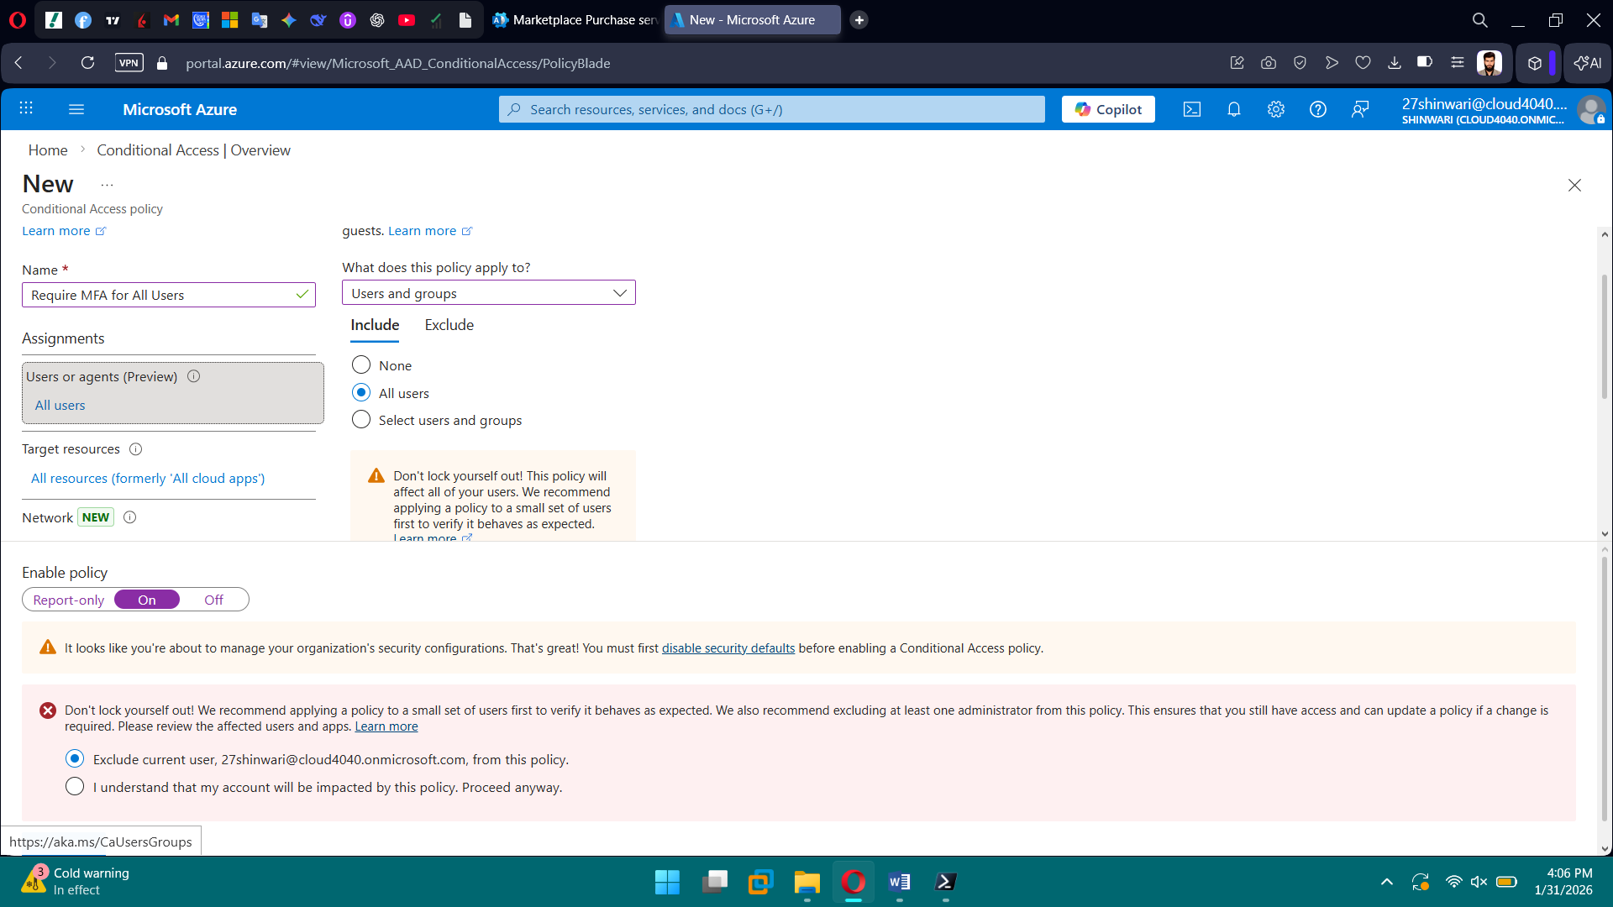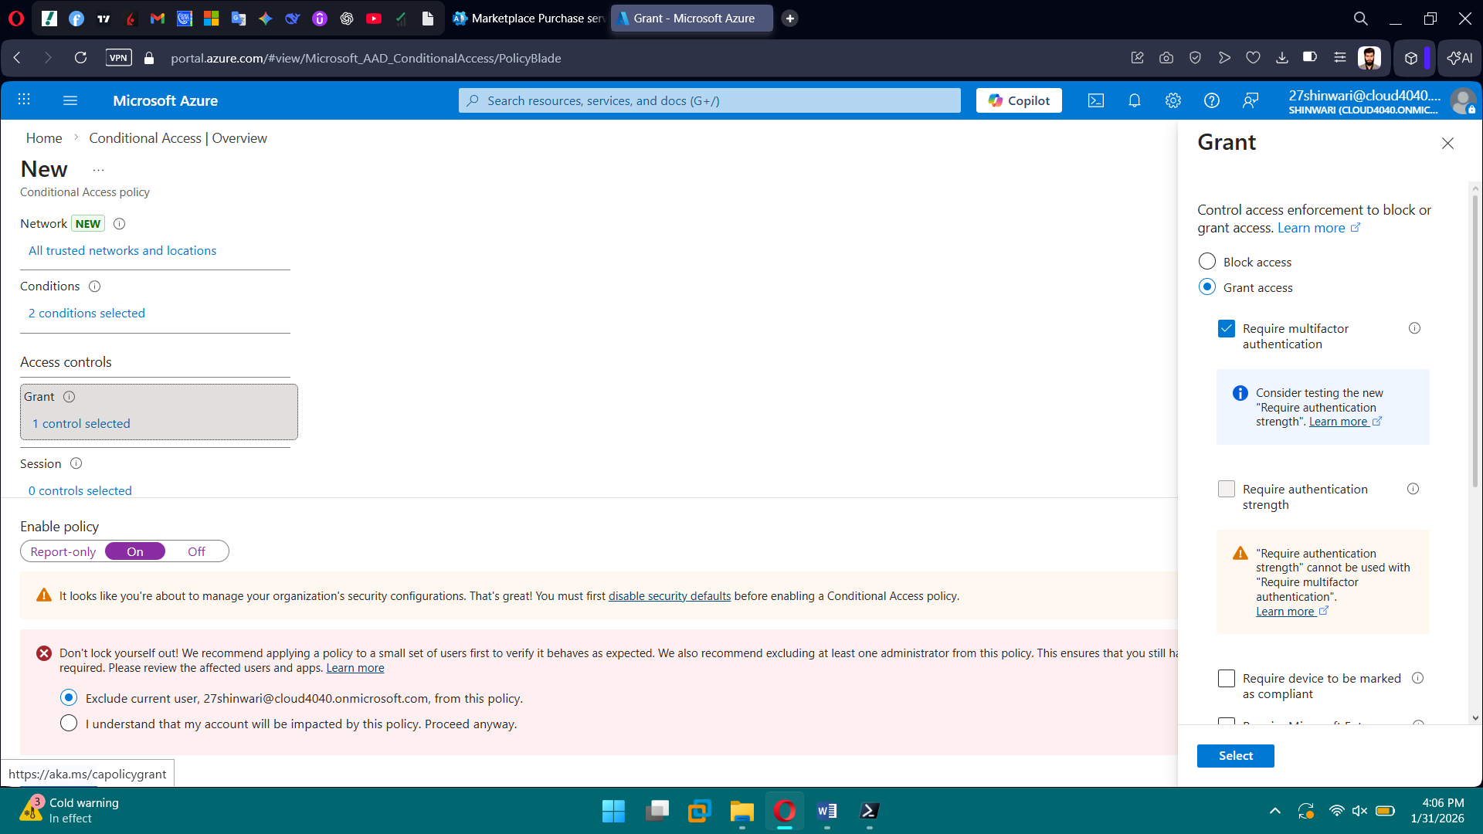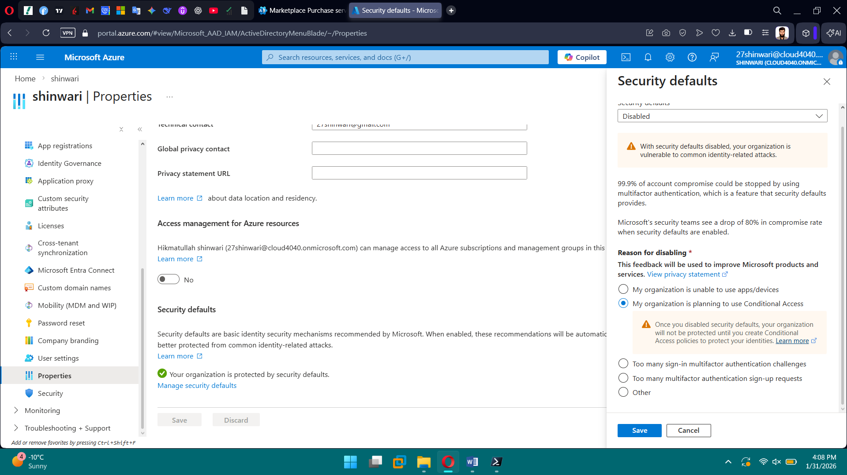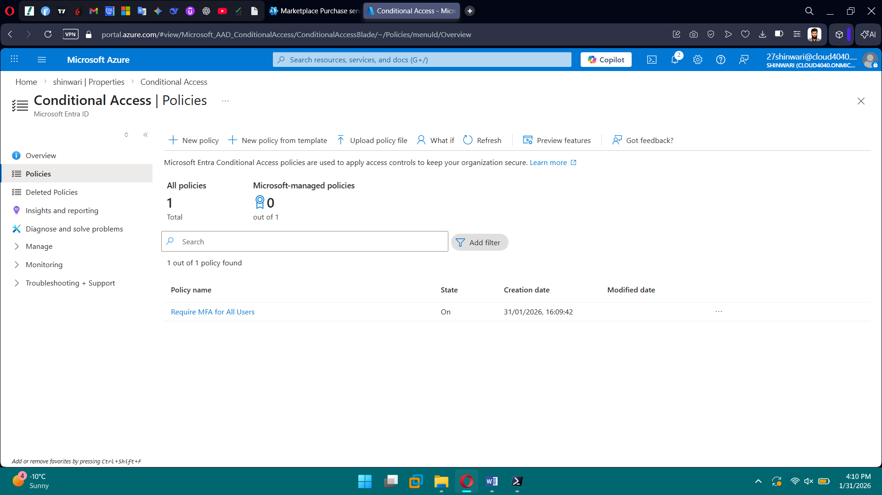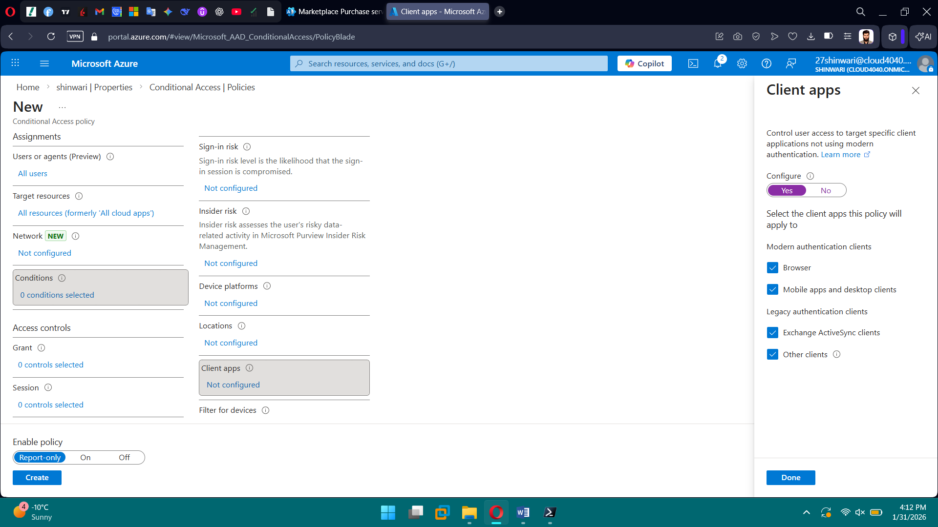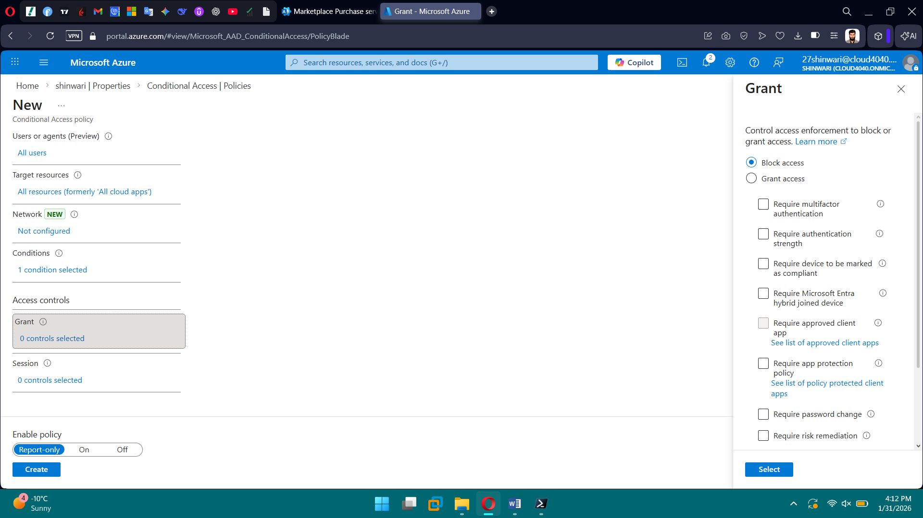

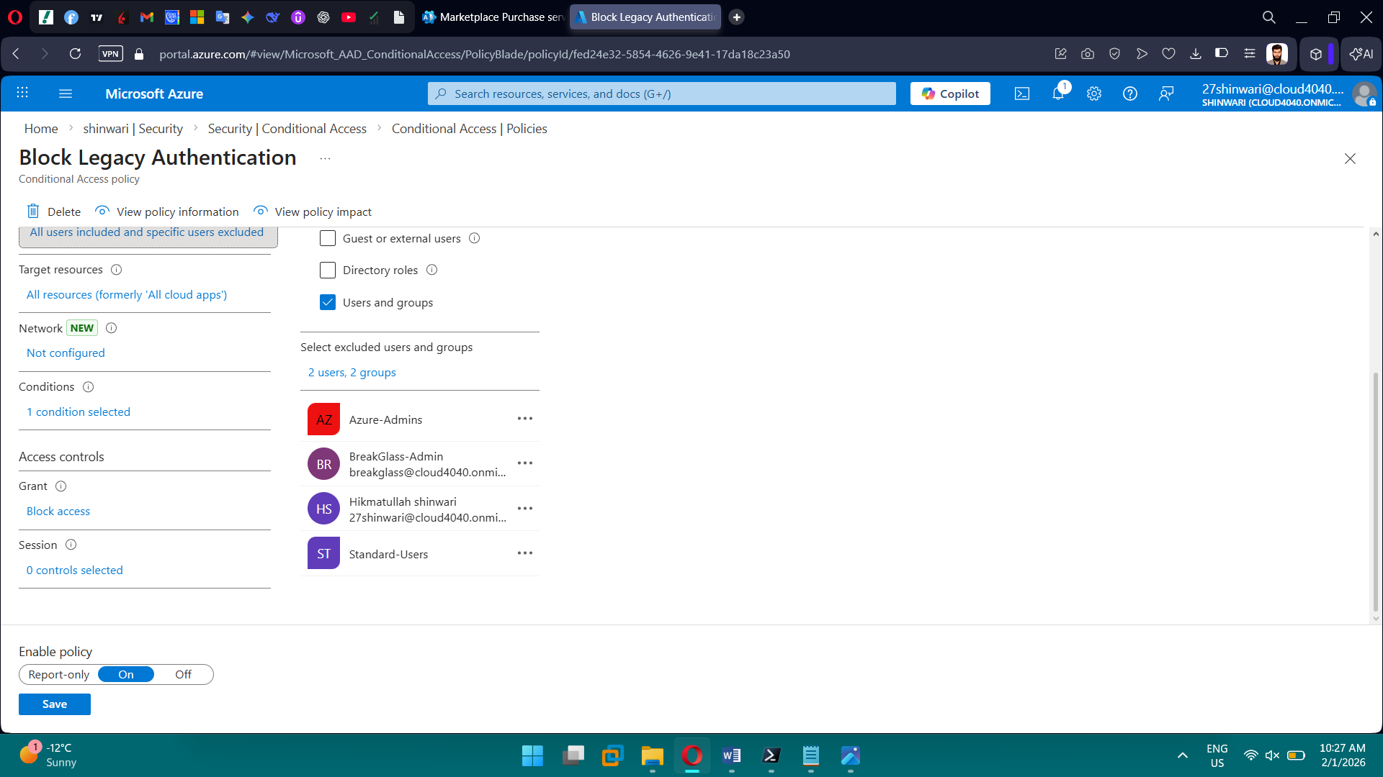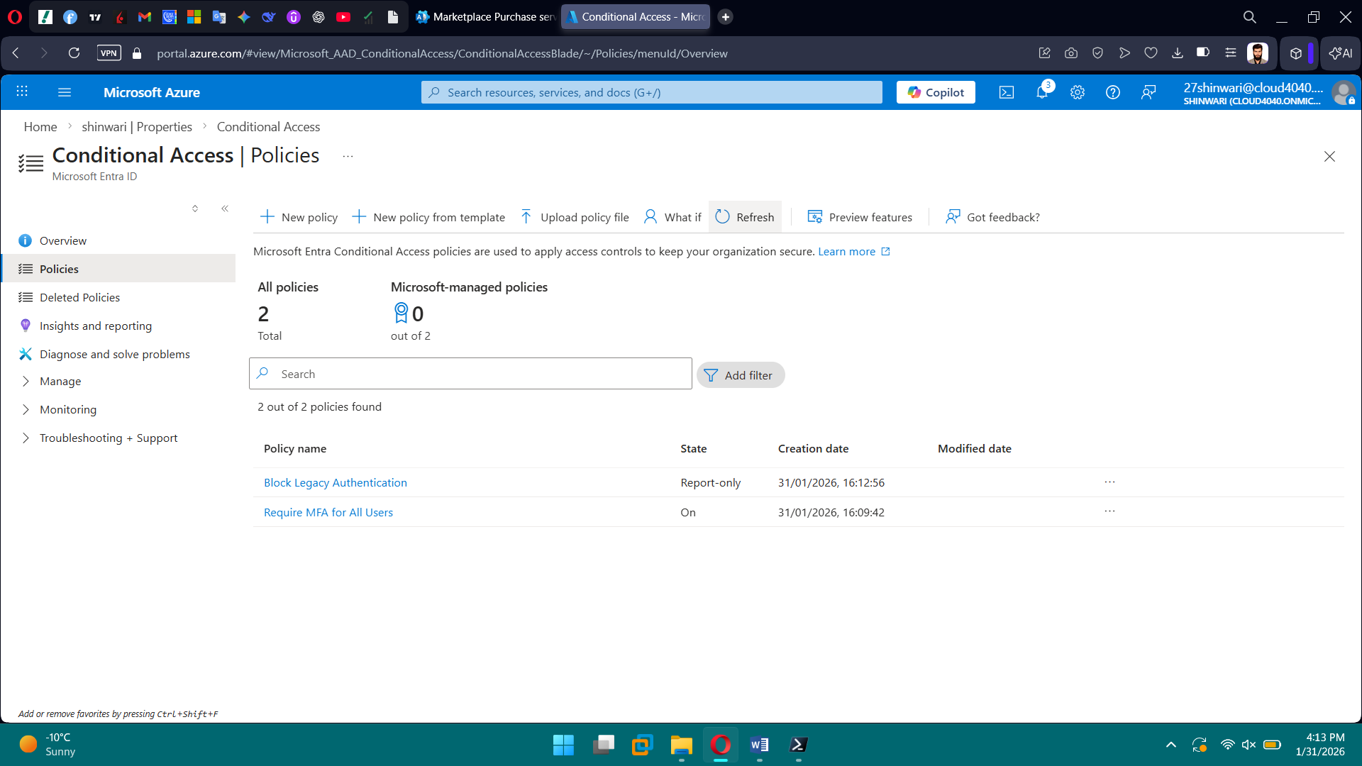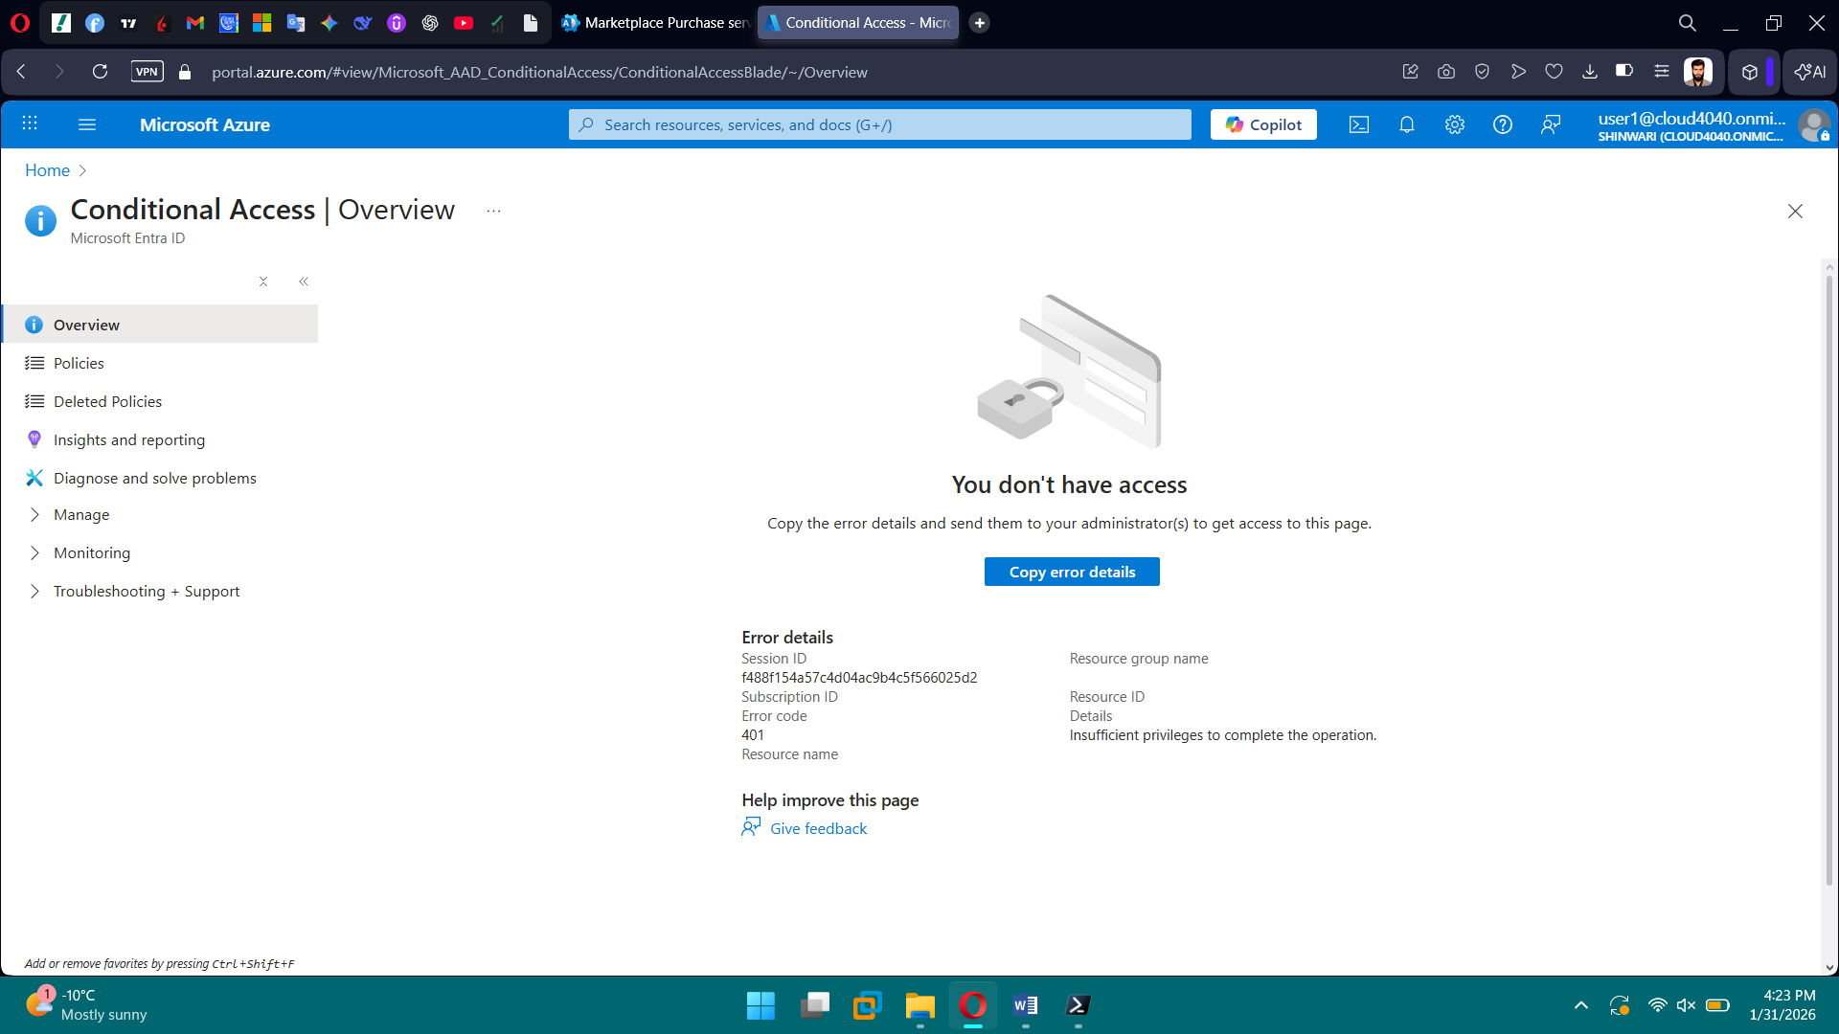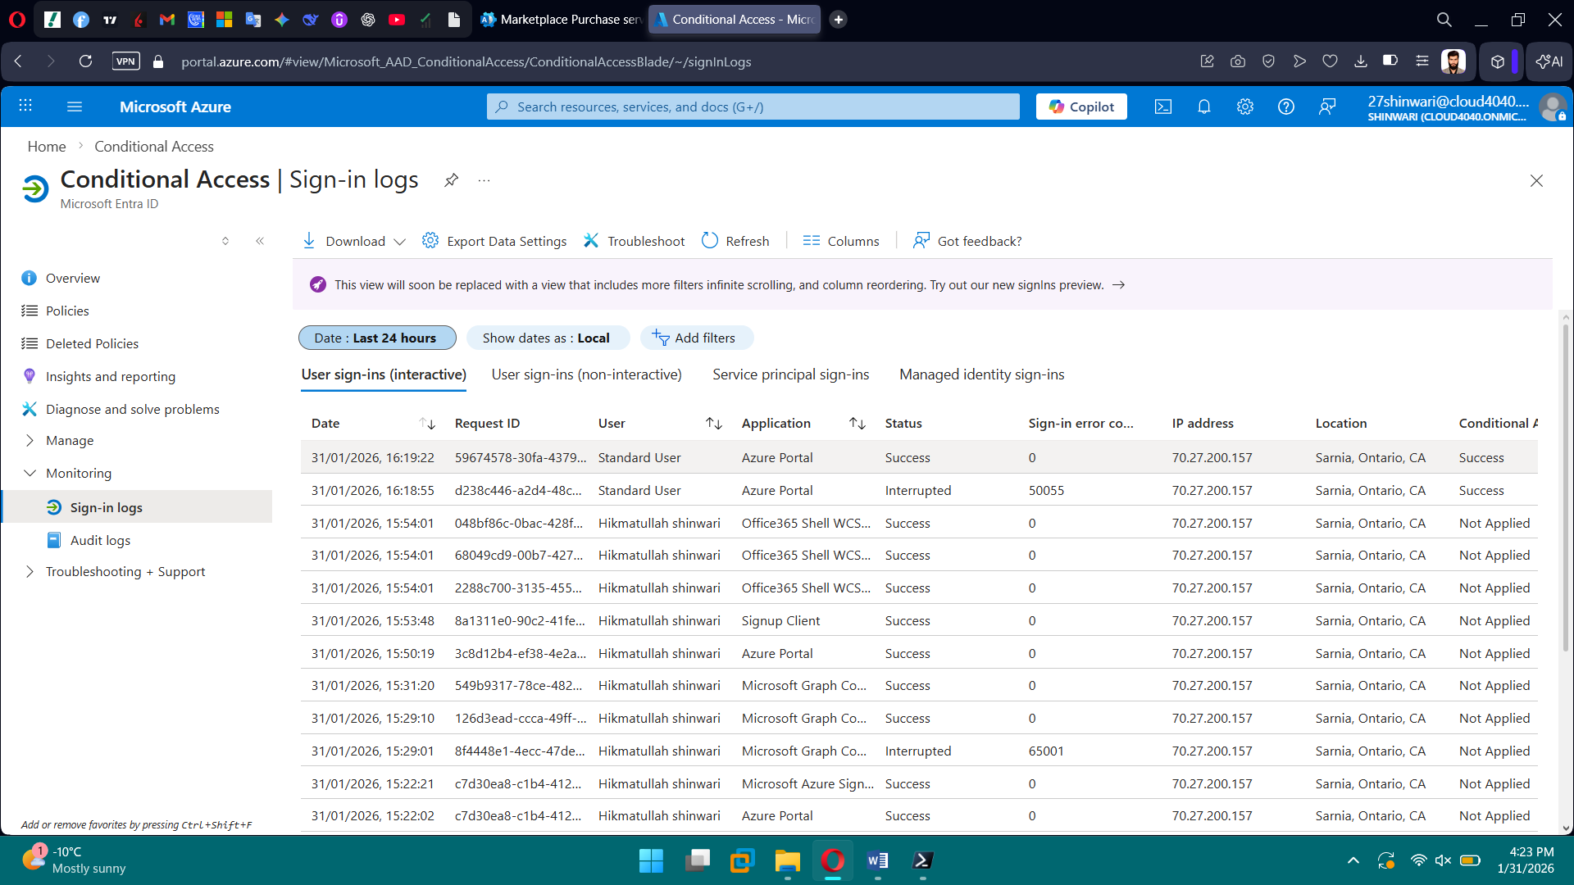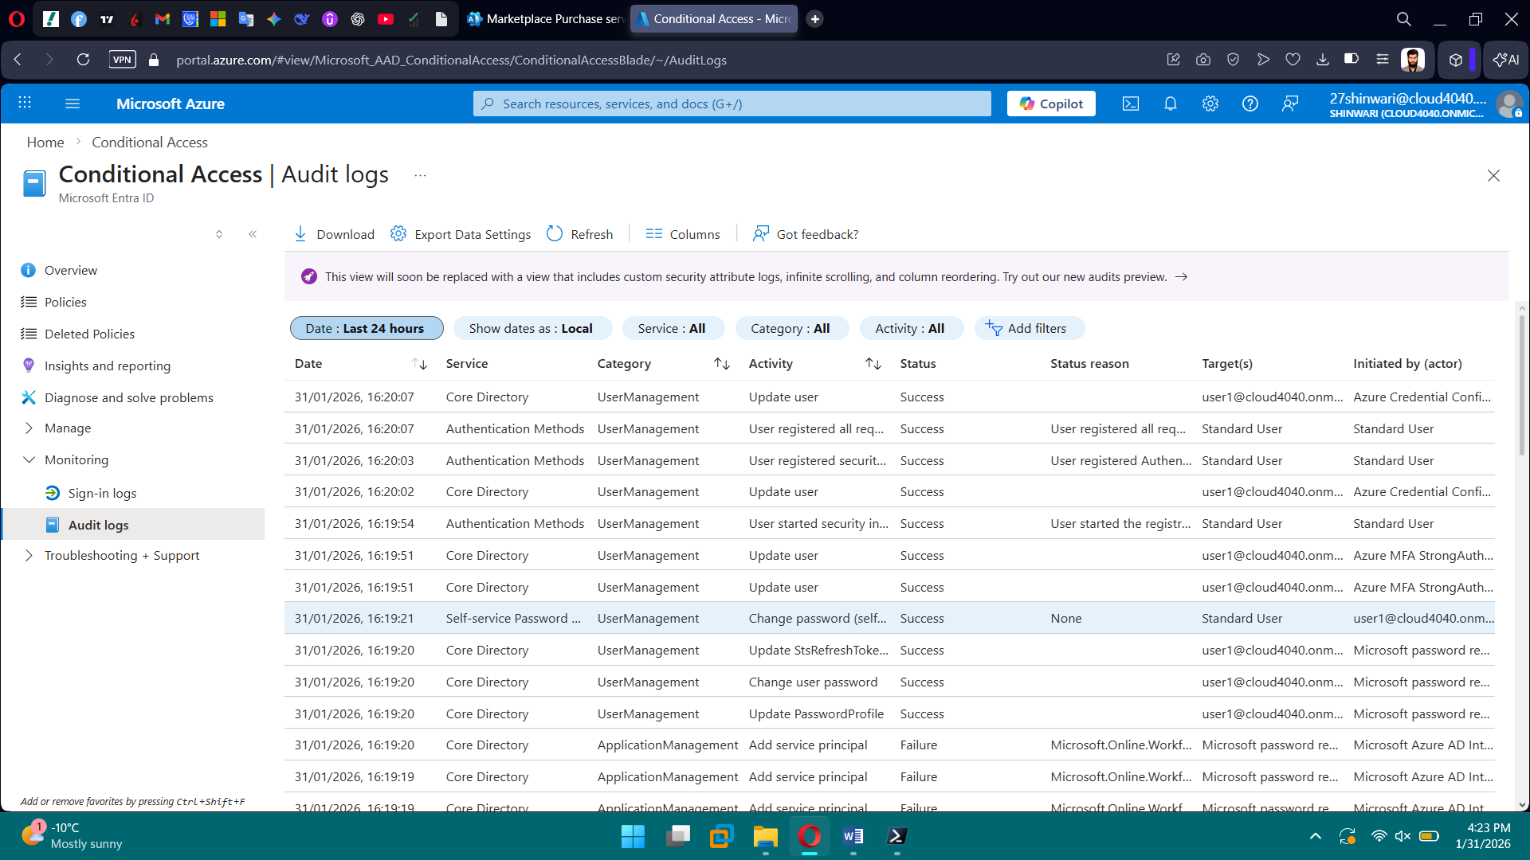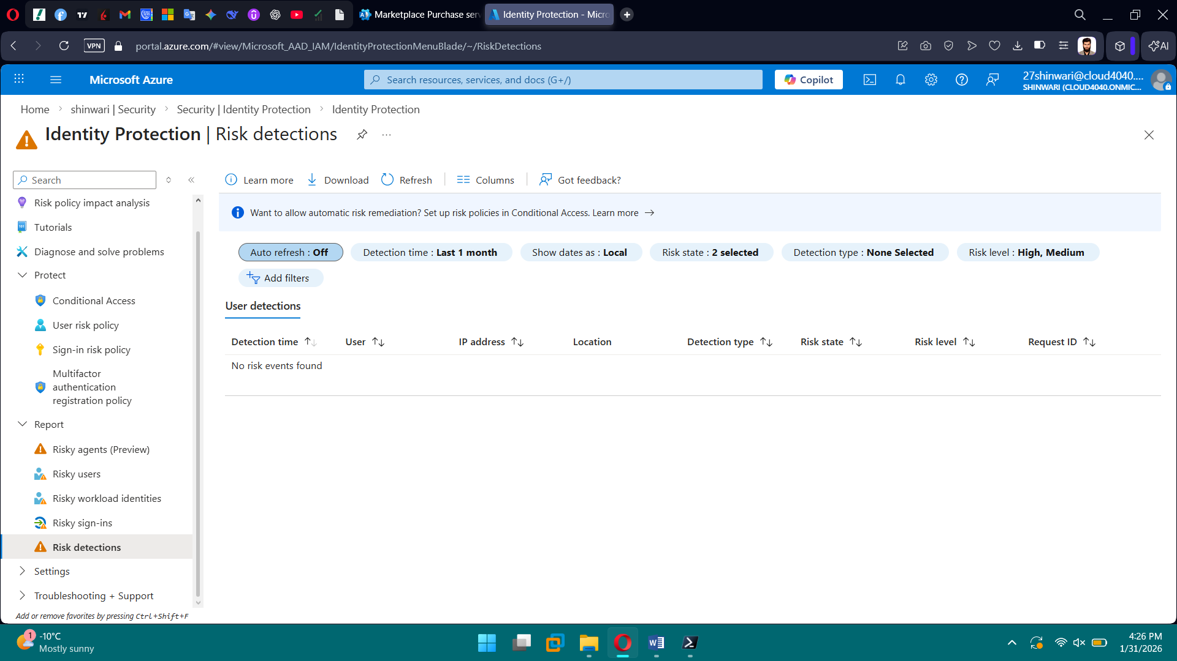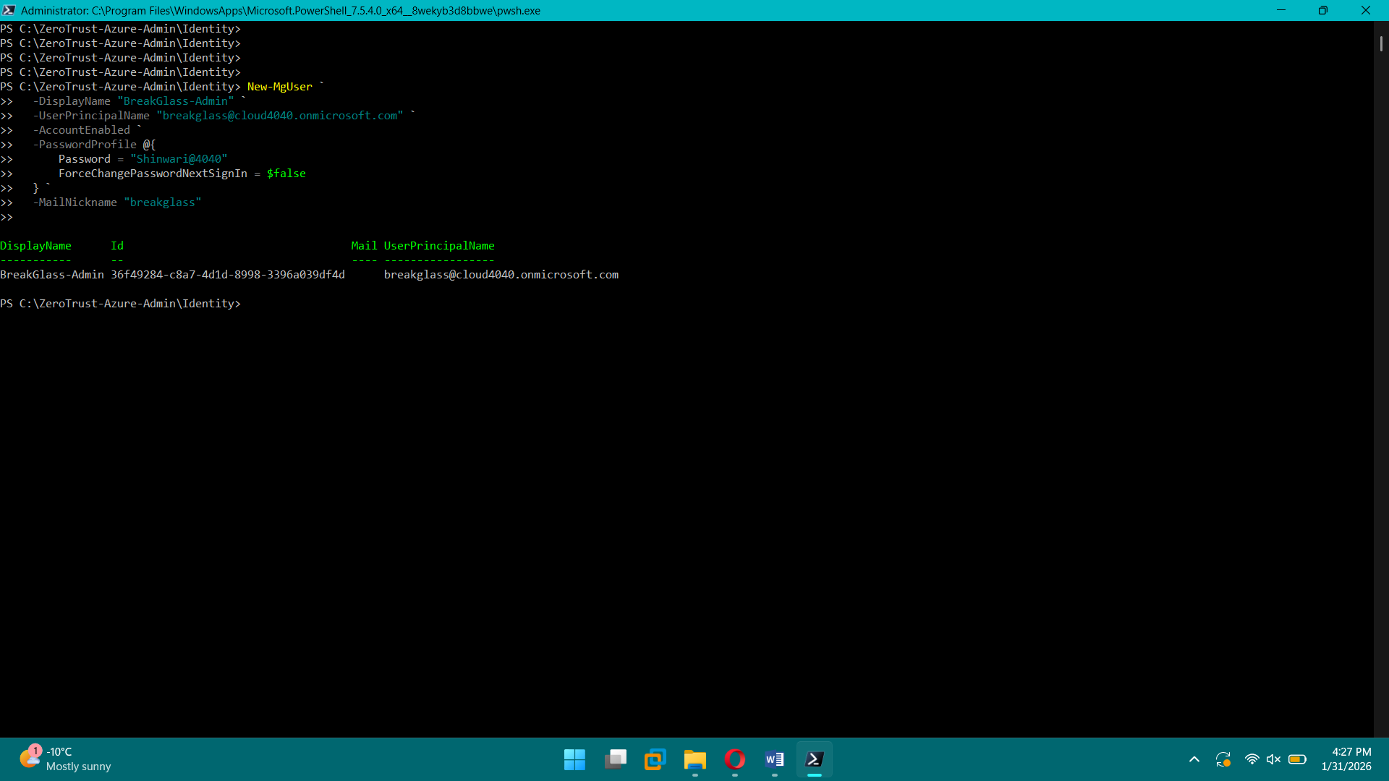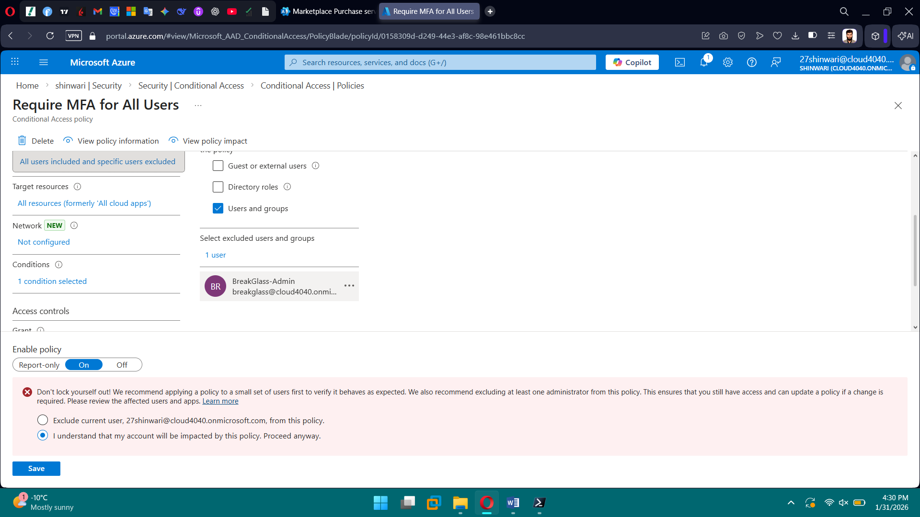 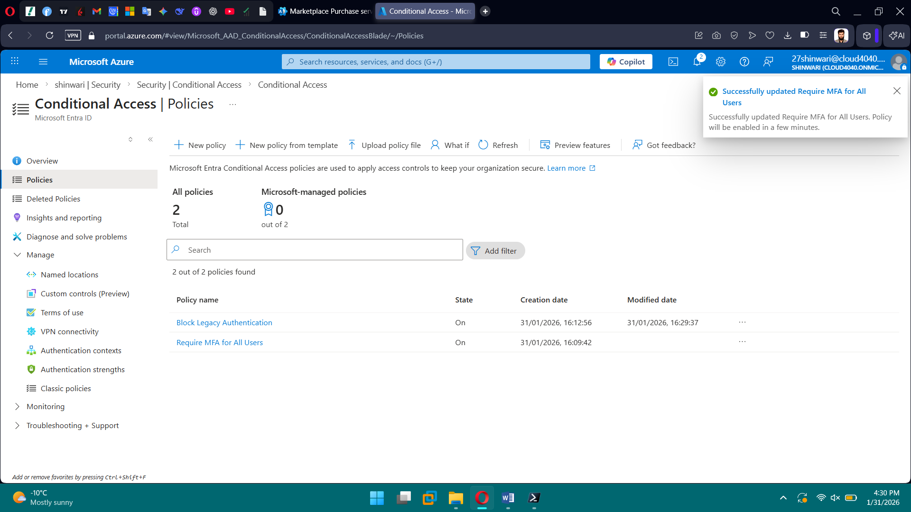

**Phase 2: Role-Based Access Control (RBAC)**

**Tasks**

* Assign built-in Azure roles using least privilege
* Create a custom RBAC role using JSON
* Assign roles at:
  + Subscription level
  + Resource Group level

**Brief Explanation:** Applied least-privilege access using built-in Azure roles at subscription and resource group scopes. Designed and created a custom RBAC role to allow VM operations without infrastructure modification. Assigned roles using correct scopes and validated access. Audited role assignments to ensure separation of duties.

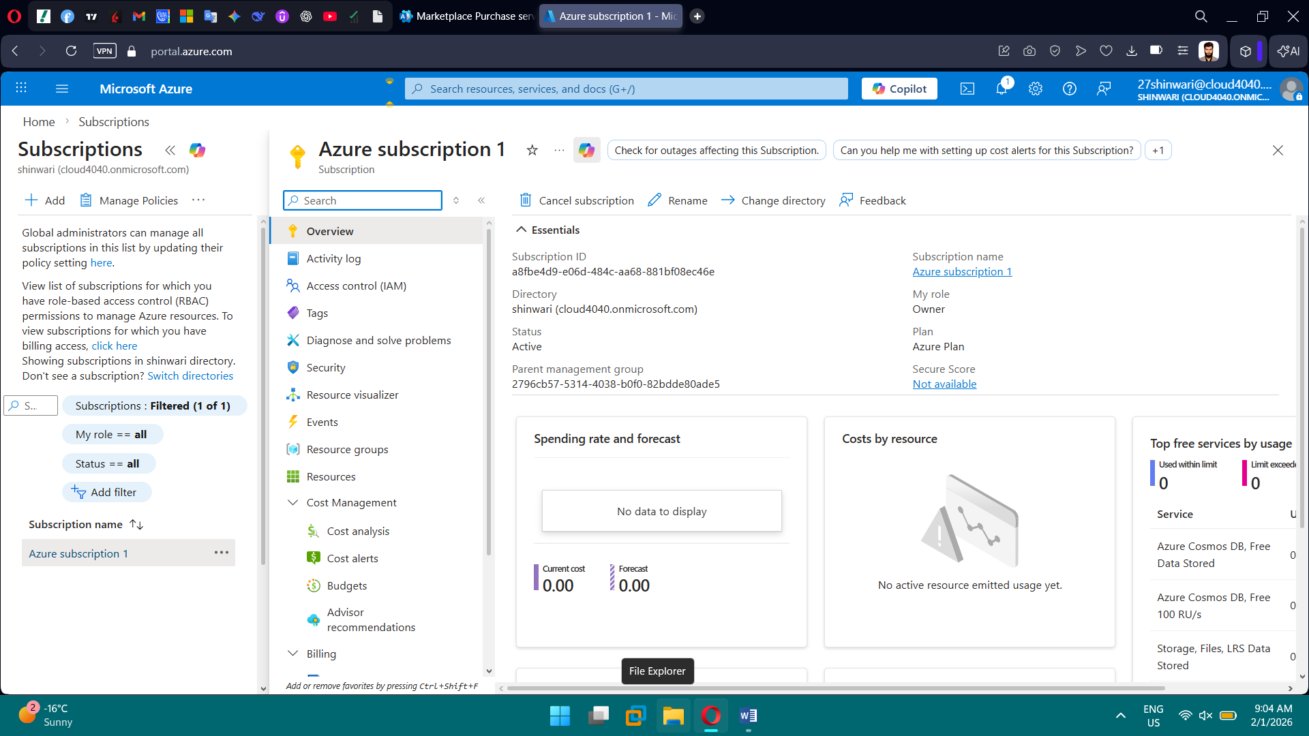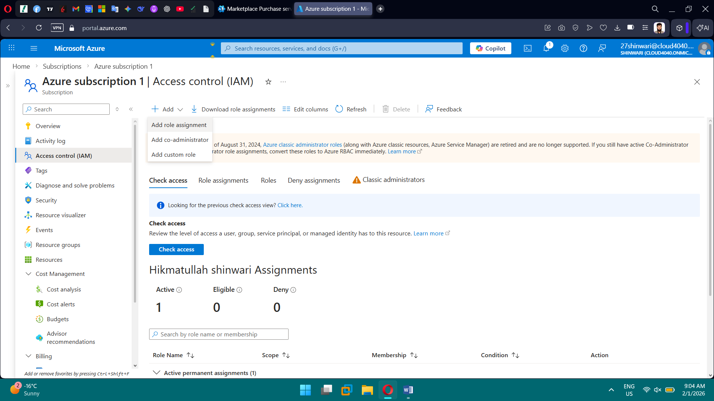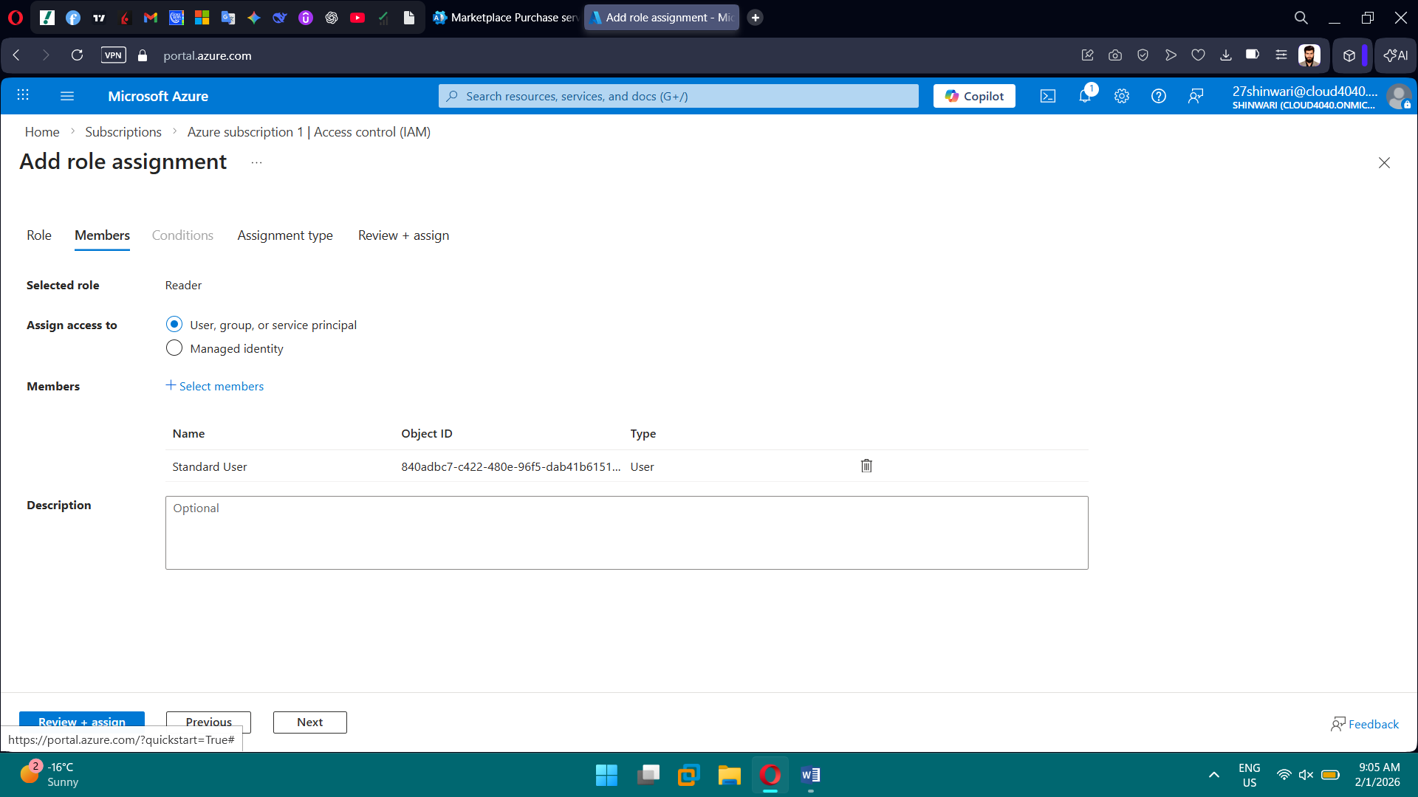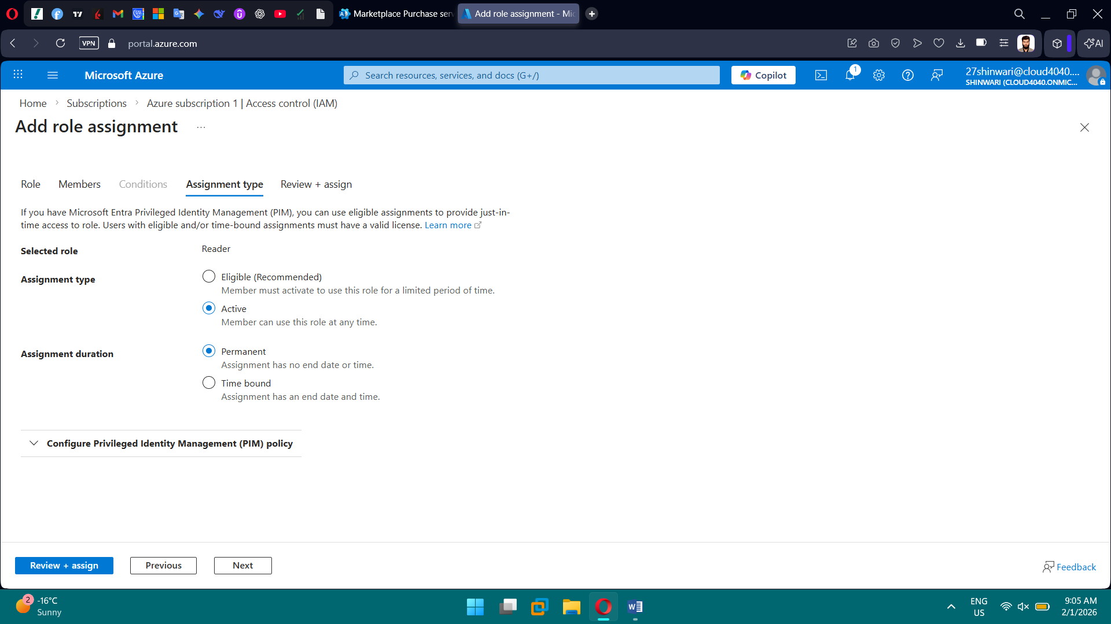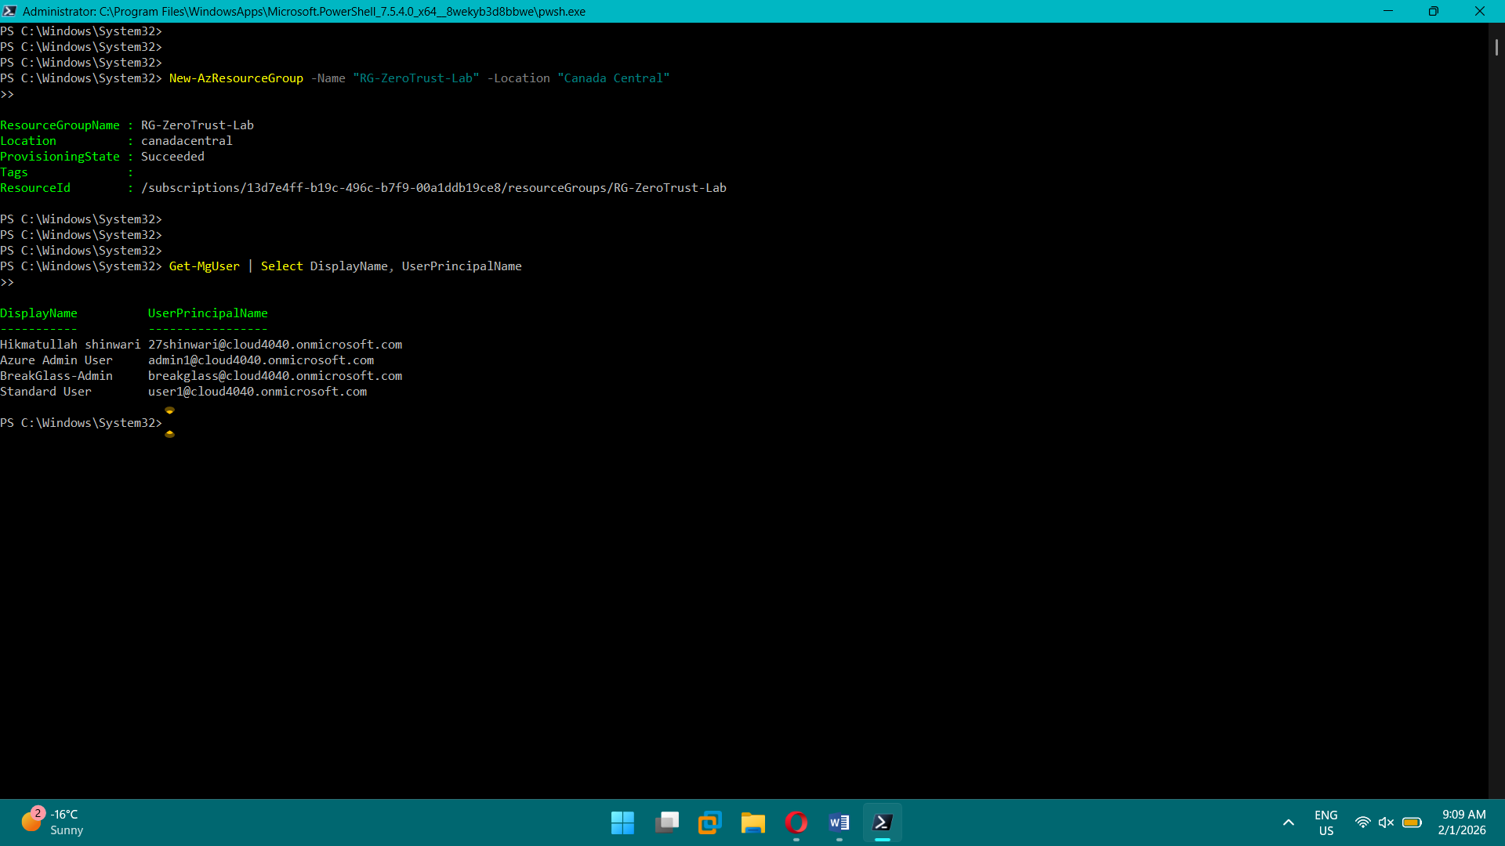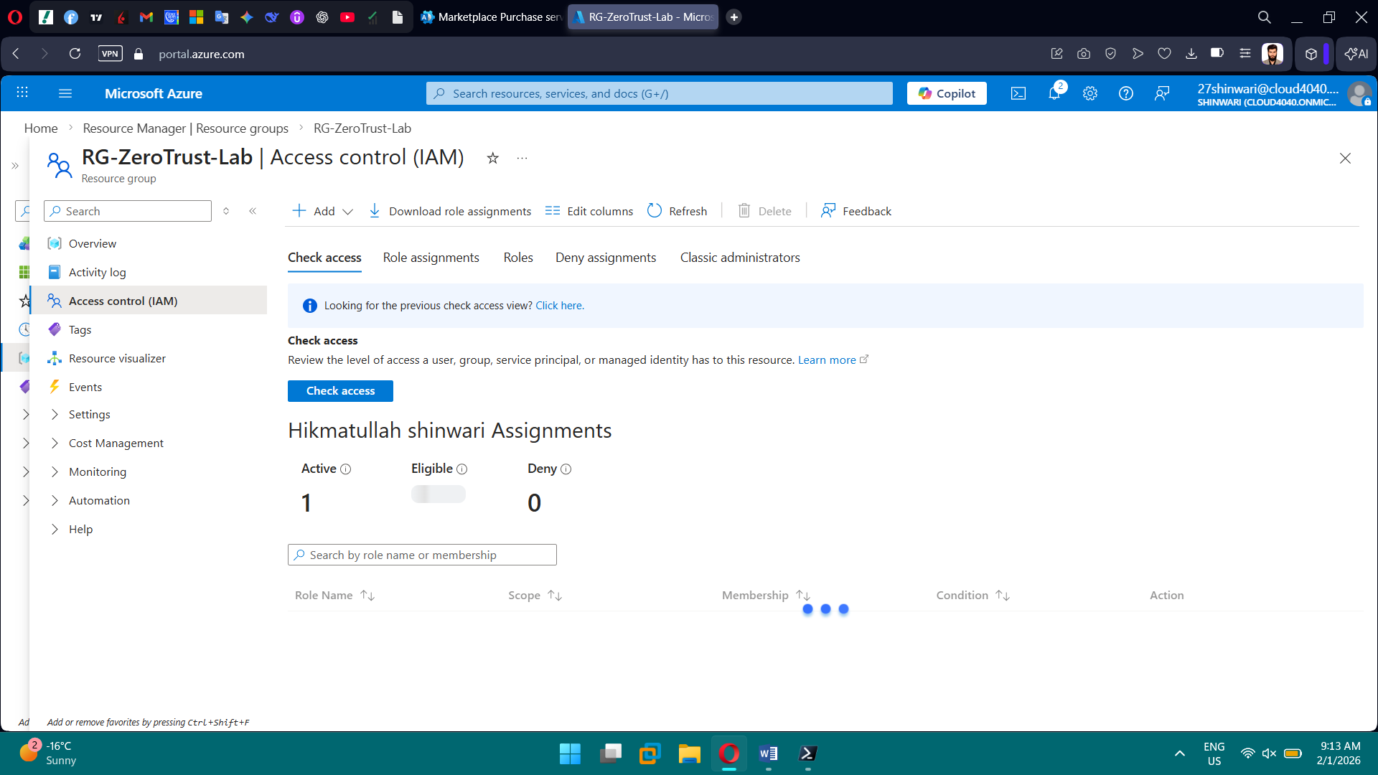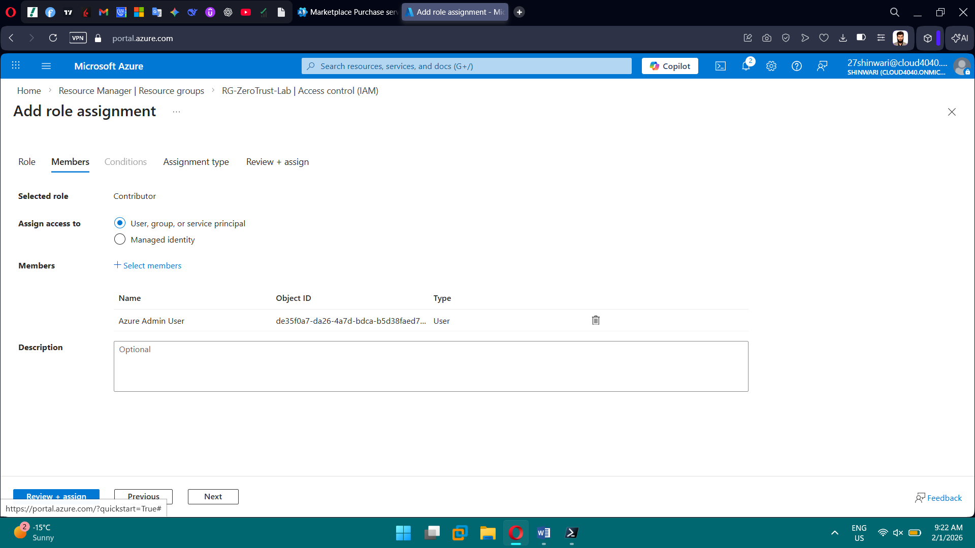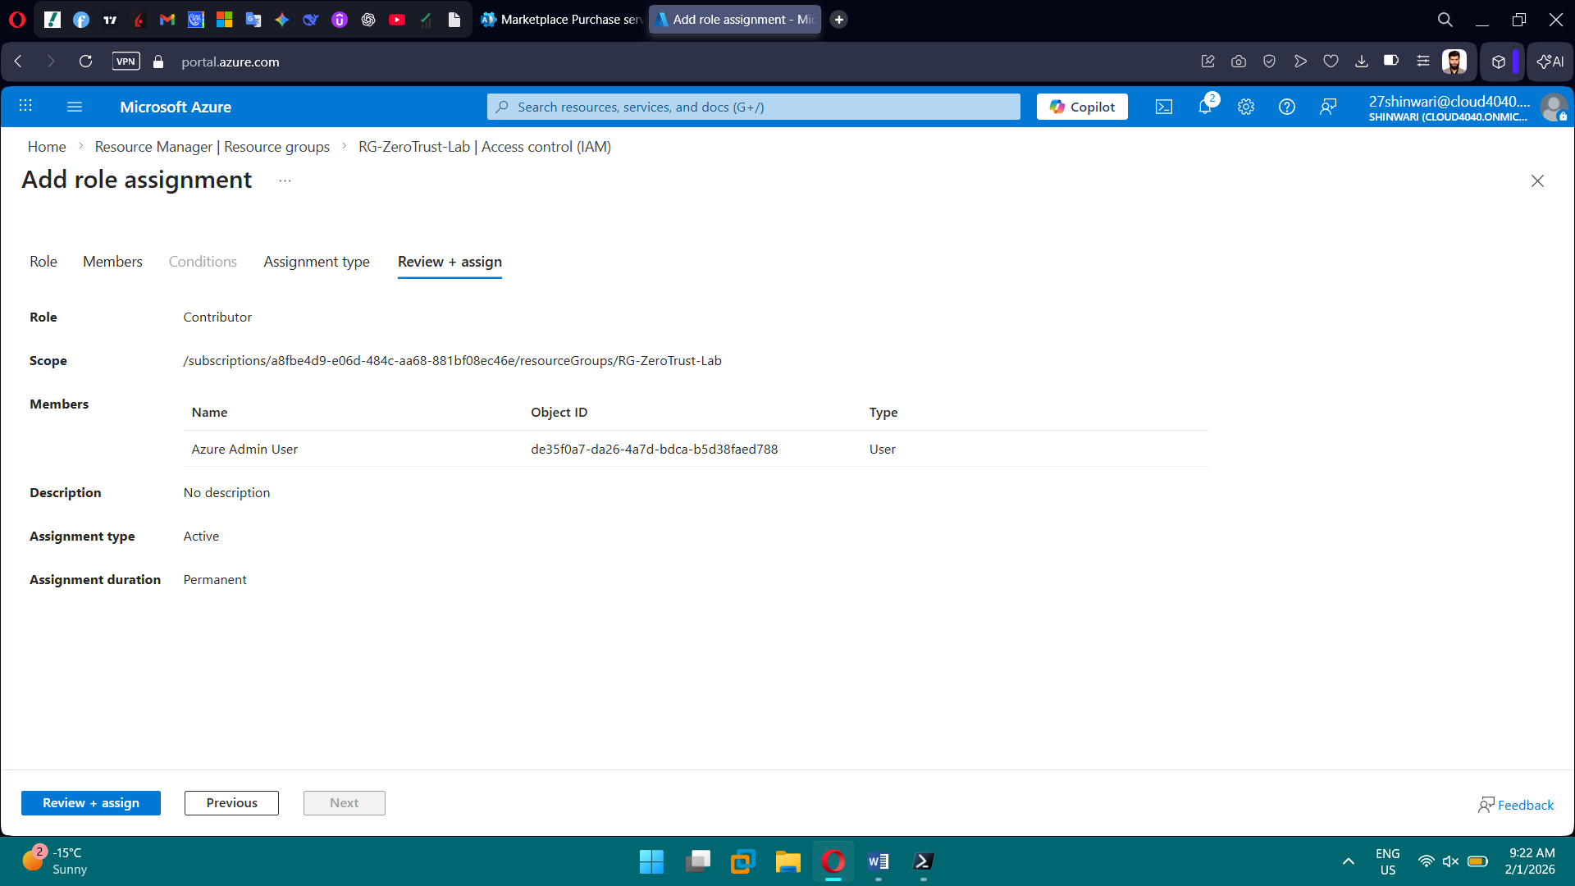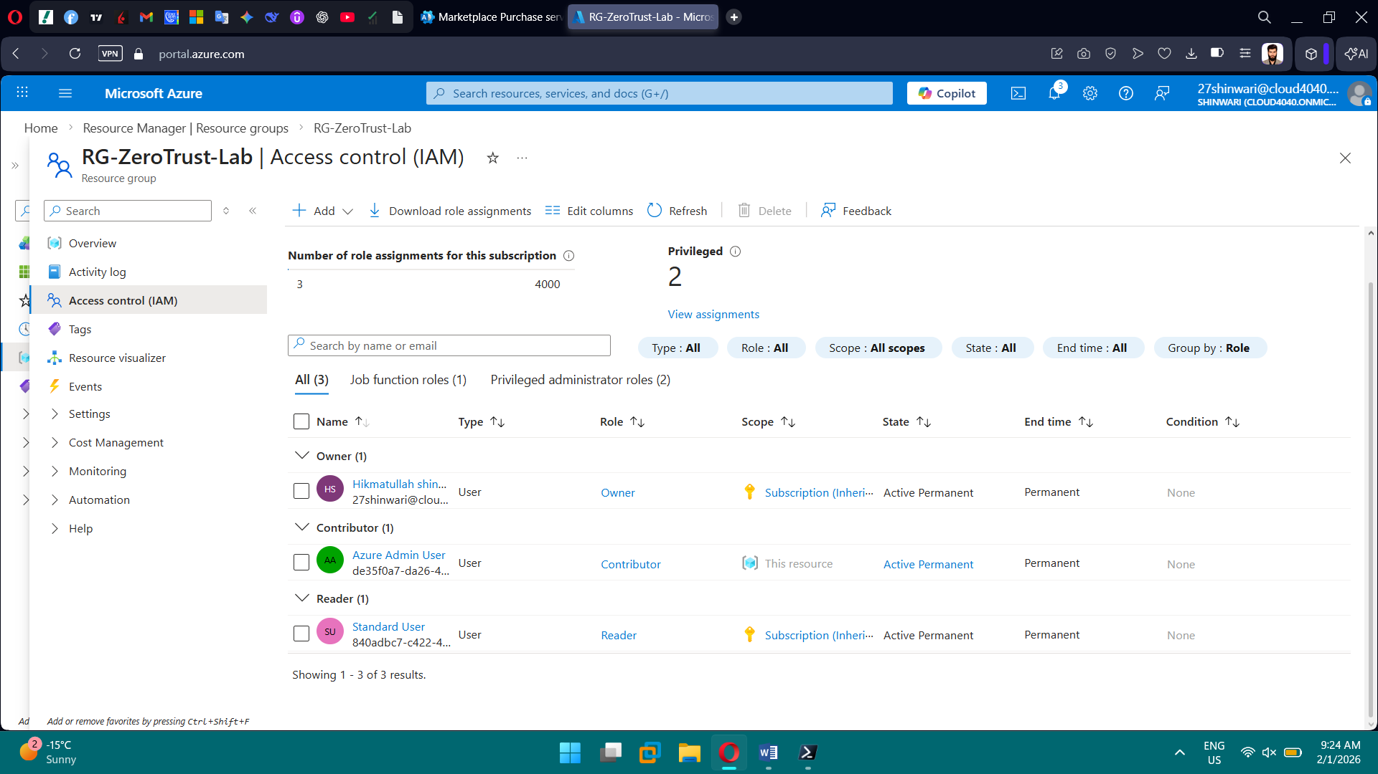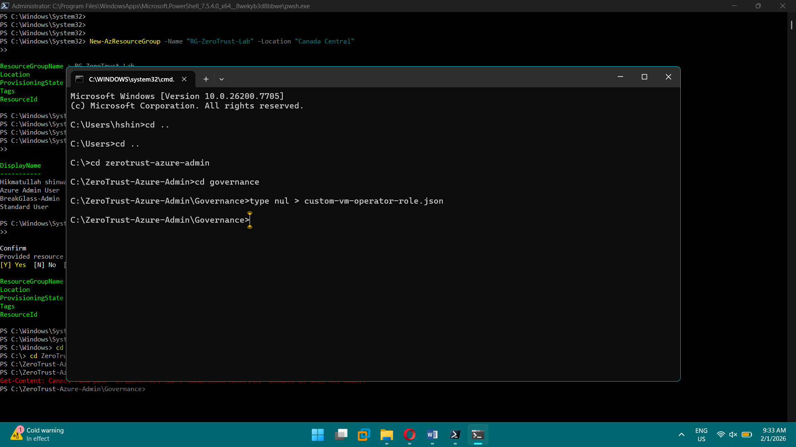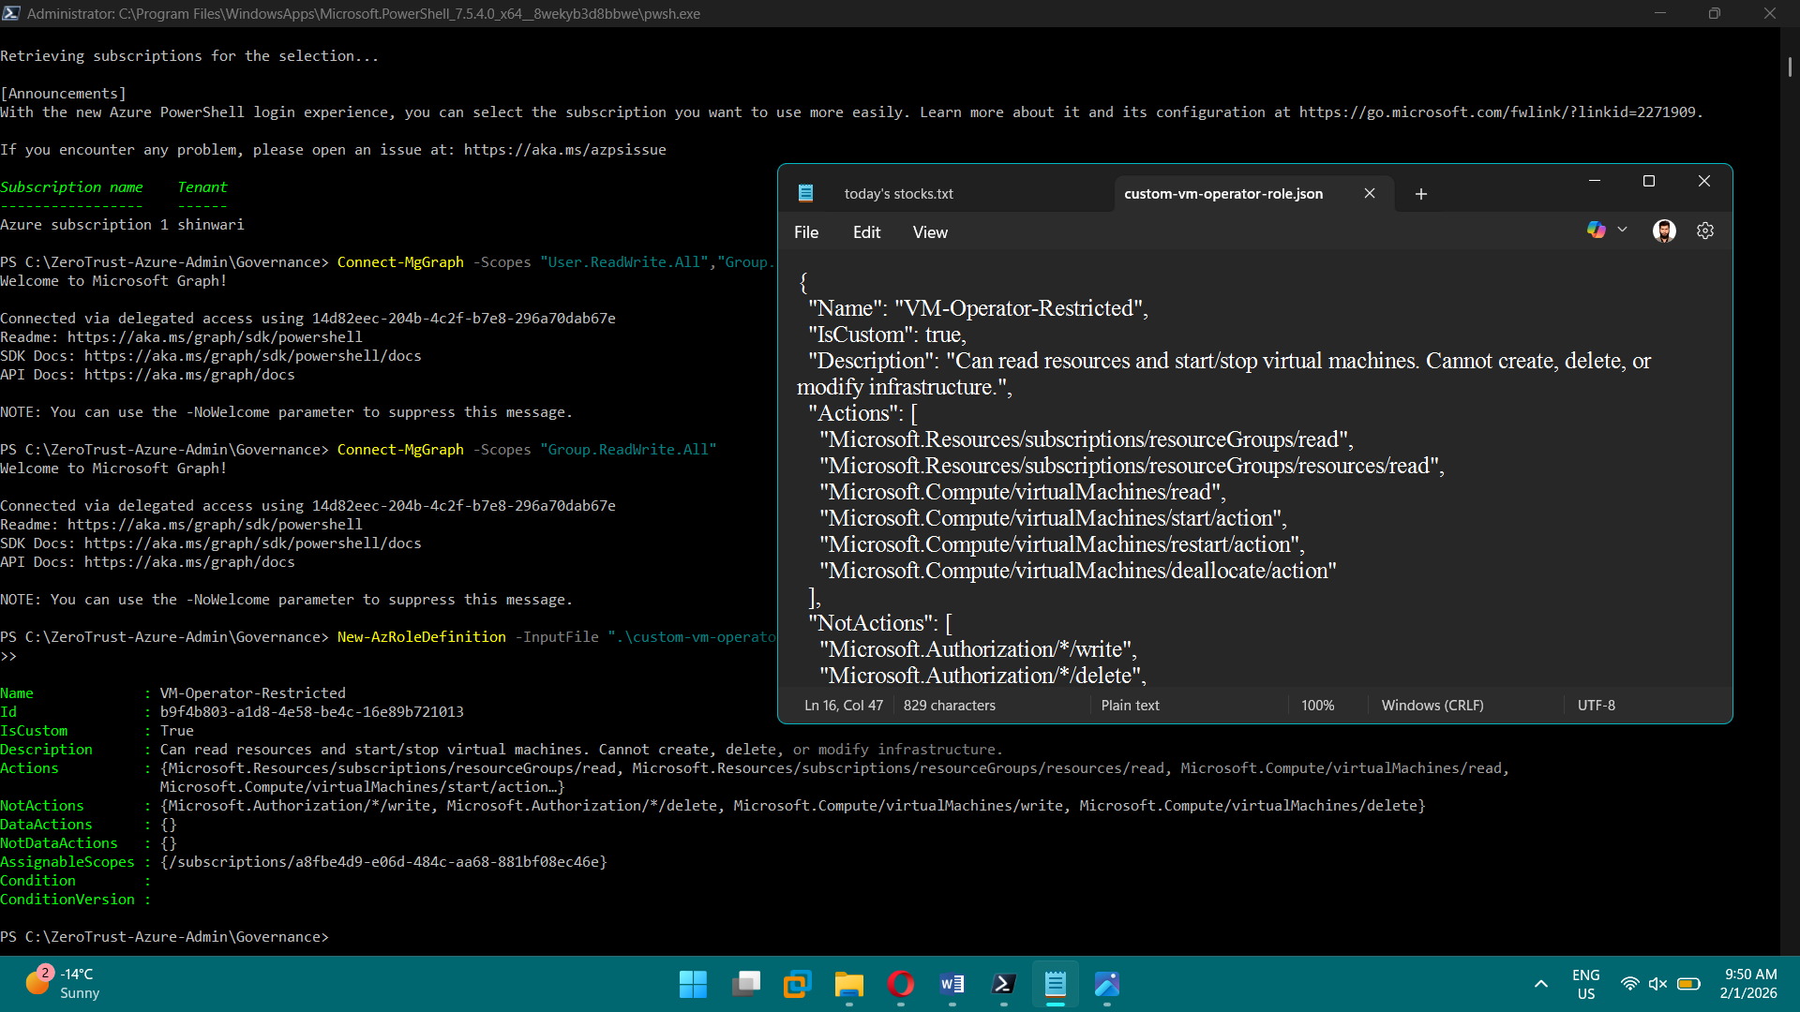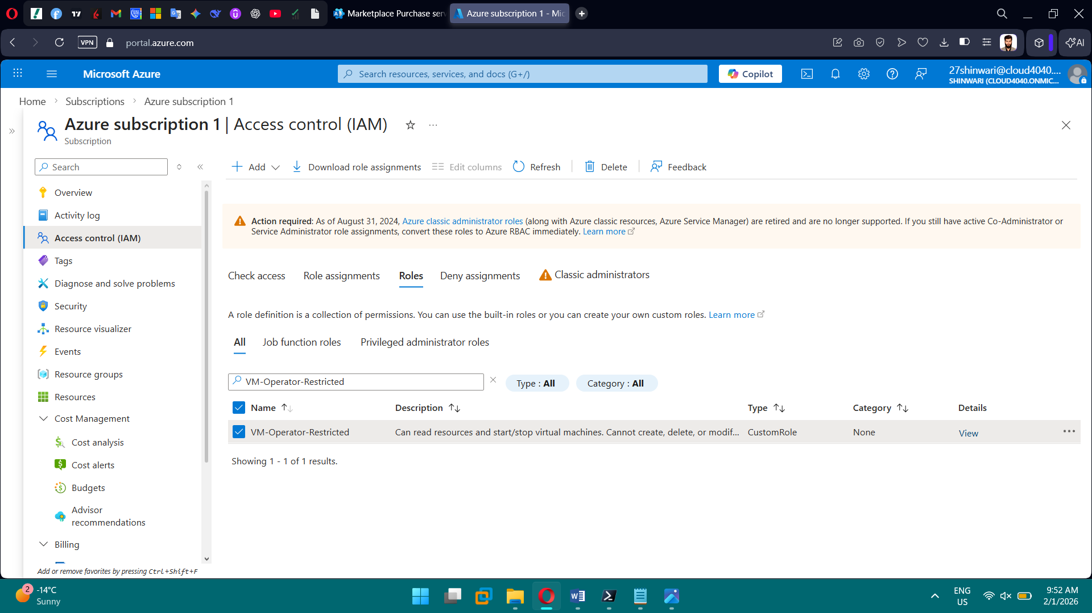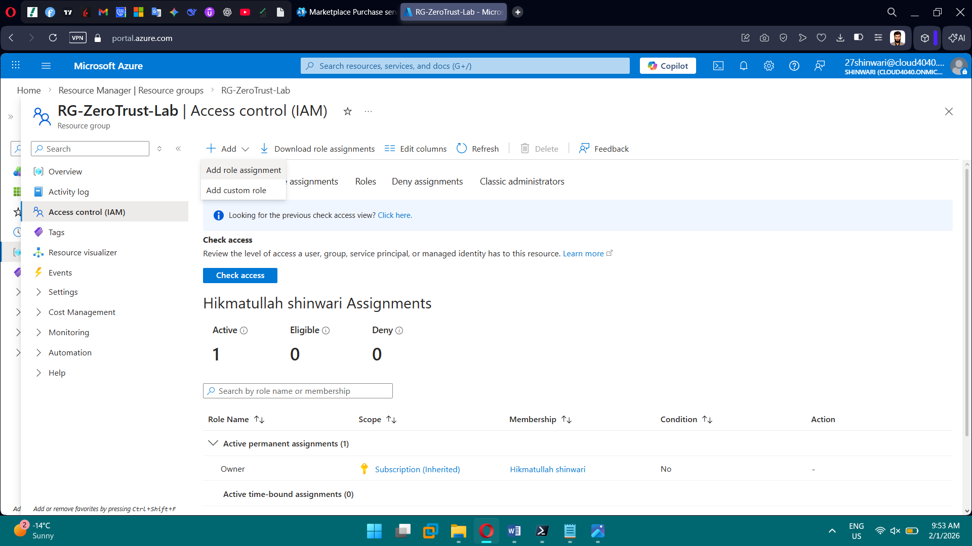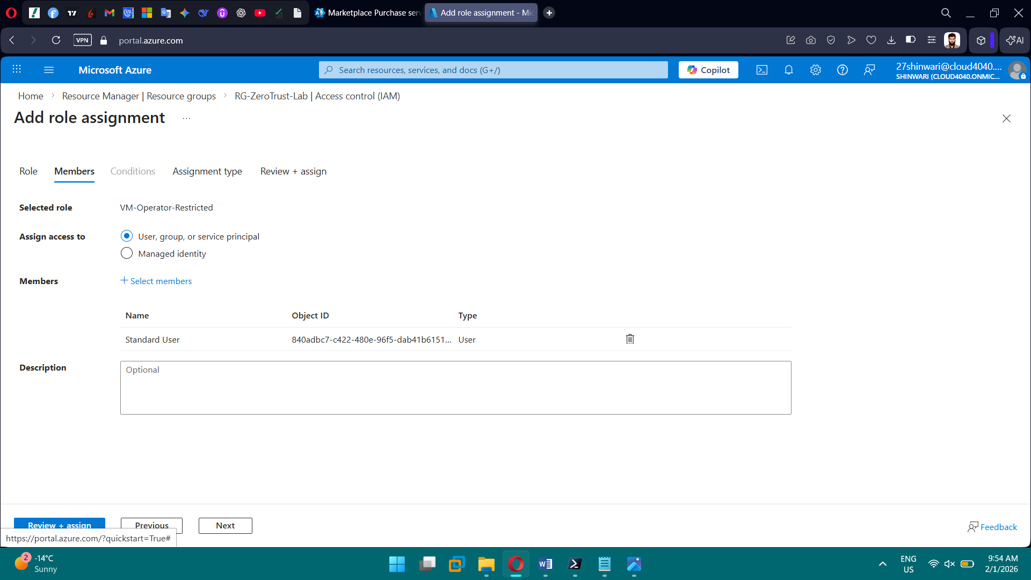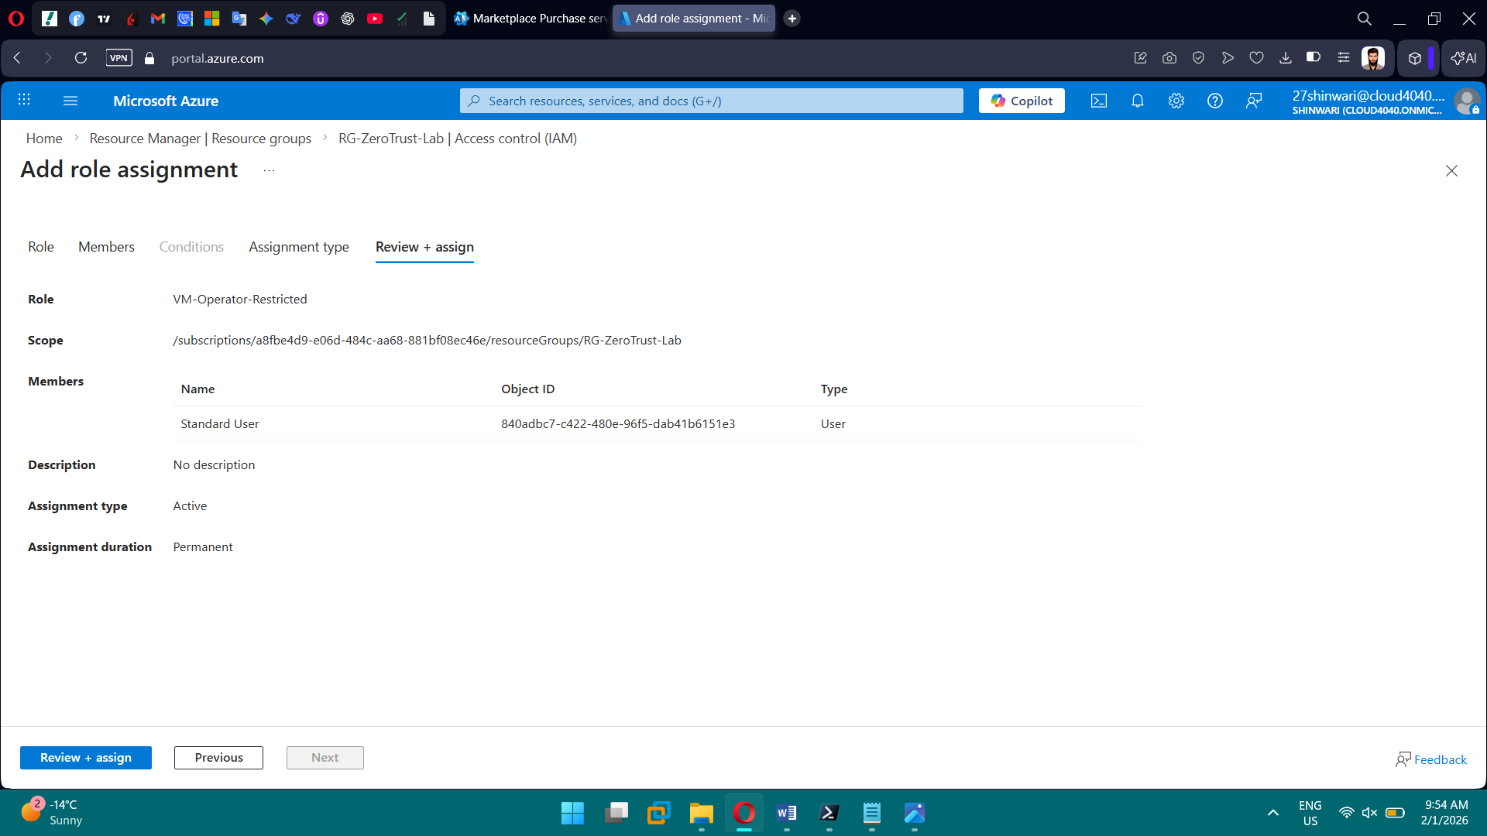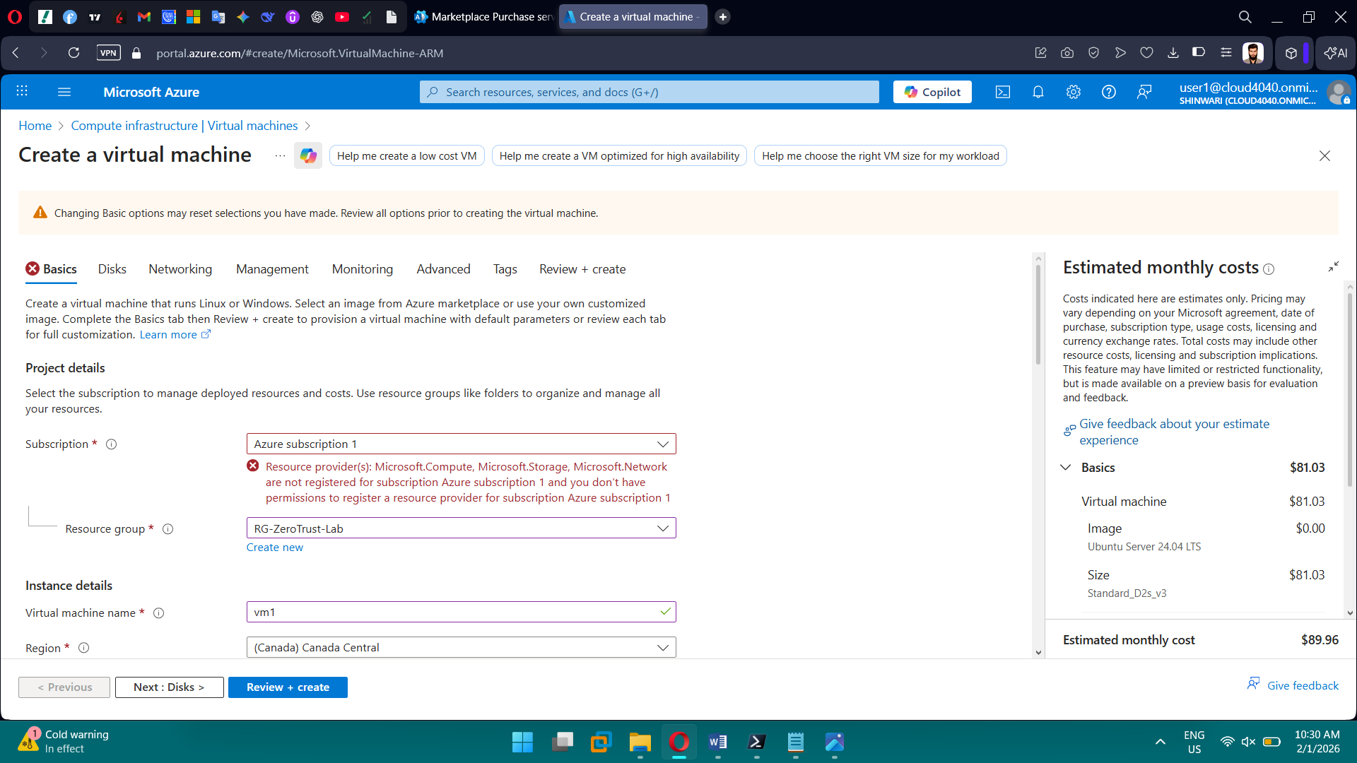

**Phase 3: Governance & Resource Control (Azure Policy)**

**Tasks**

* Enforce mandatory resource tags
* Restrict resource deployment locations
* Assign policies at the subscription scope
* Review compliance and remediation options

**Brief Explanation:** Implemented Azure Policies to enforce mandatory resource tags and restrict deployments to approved regions. Assigned policies at the subscription scope with deny effects. Tested policy enforcement by attempting non-compliant deployments. Reviewed compliance status and documented remediation options.

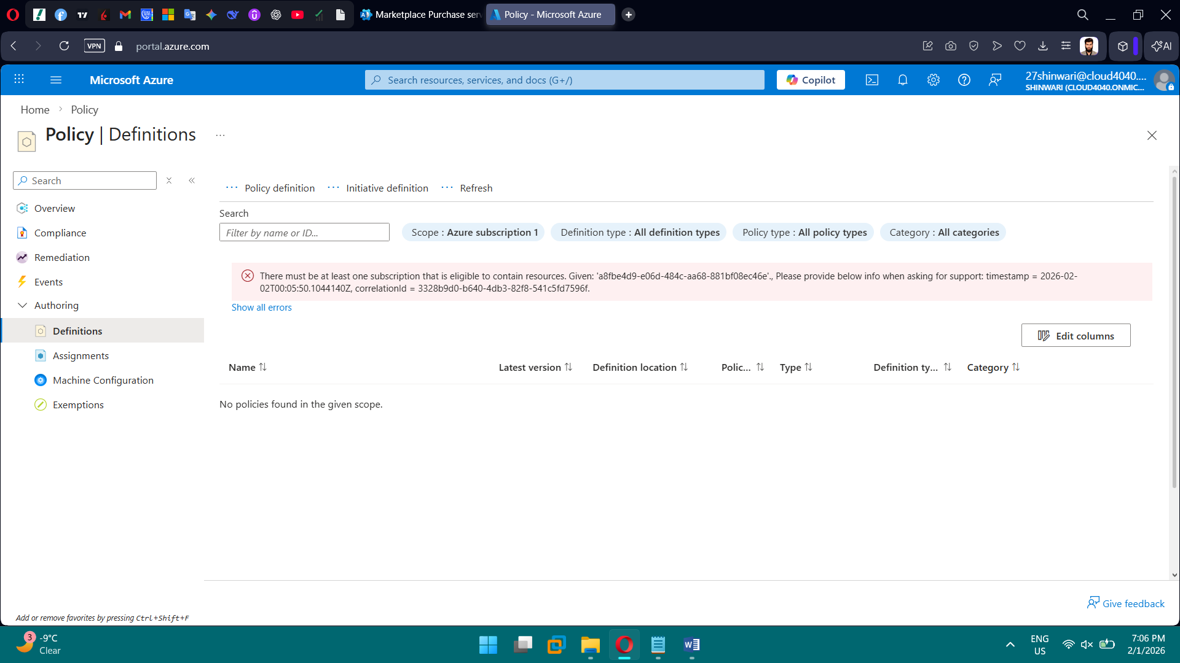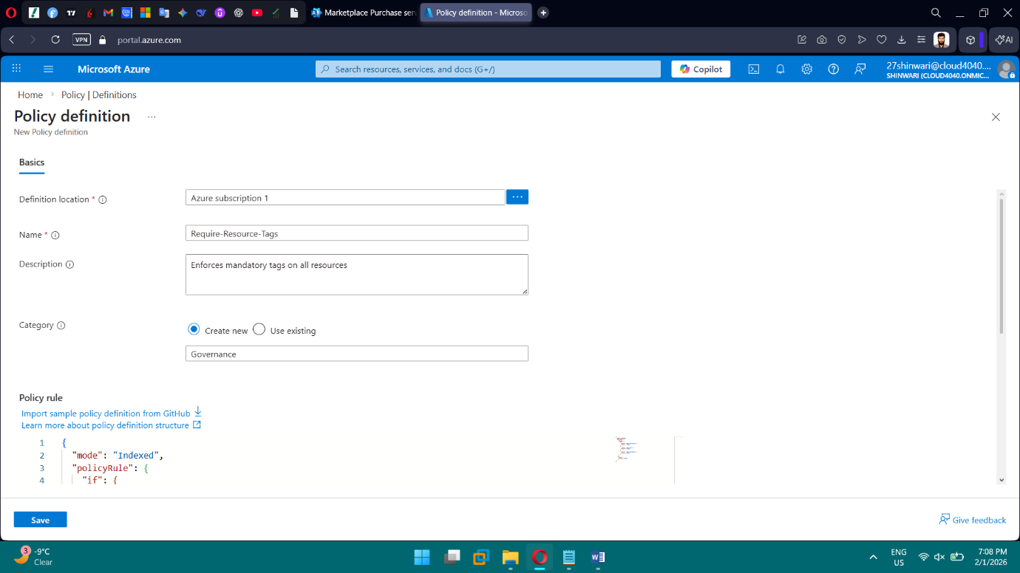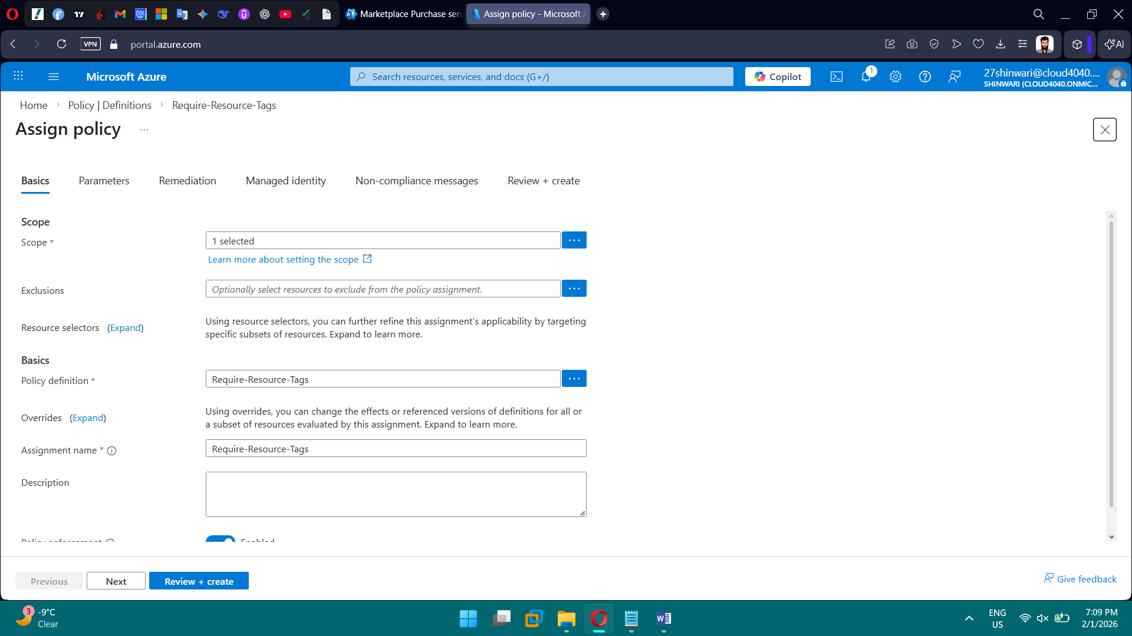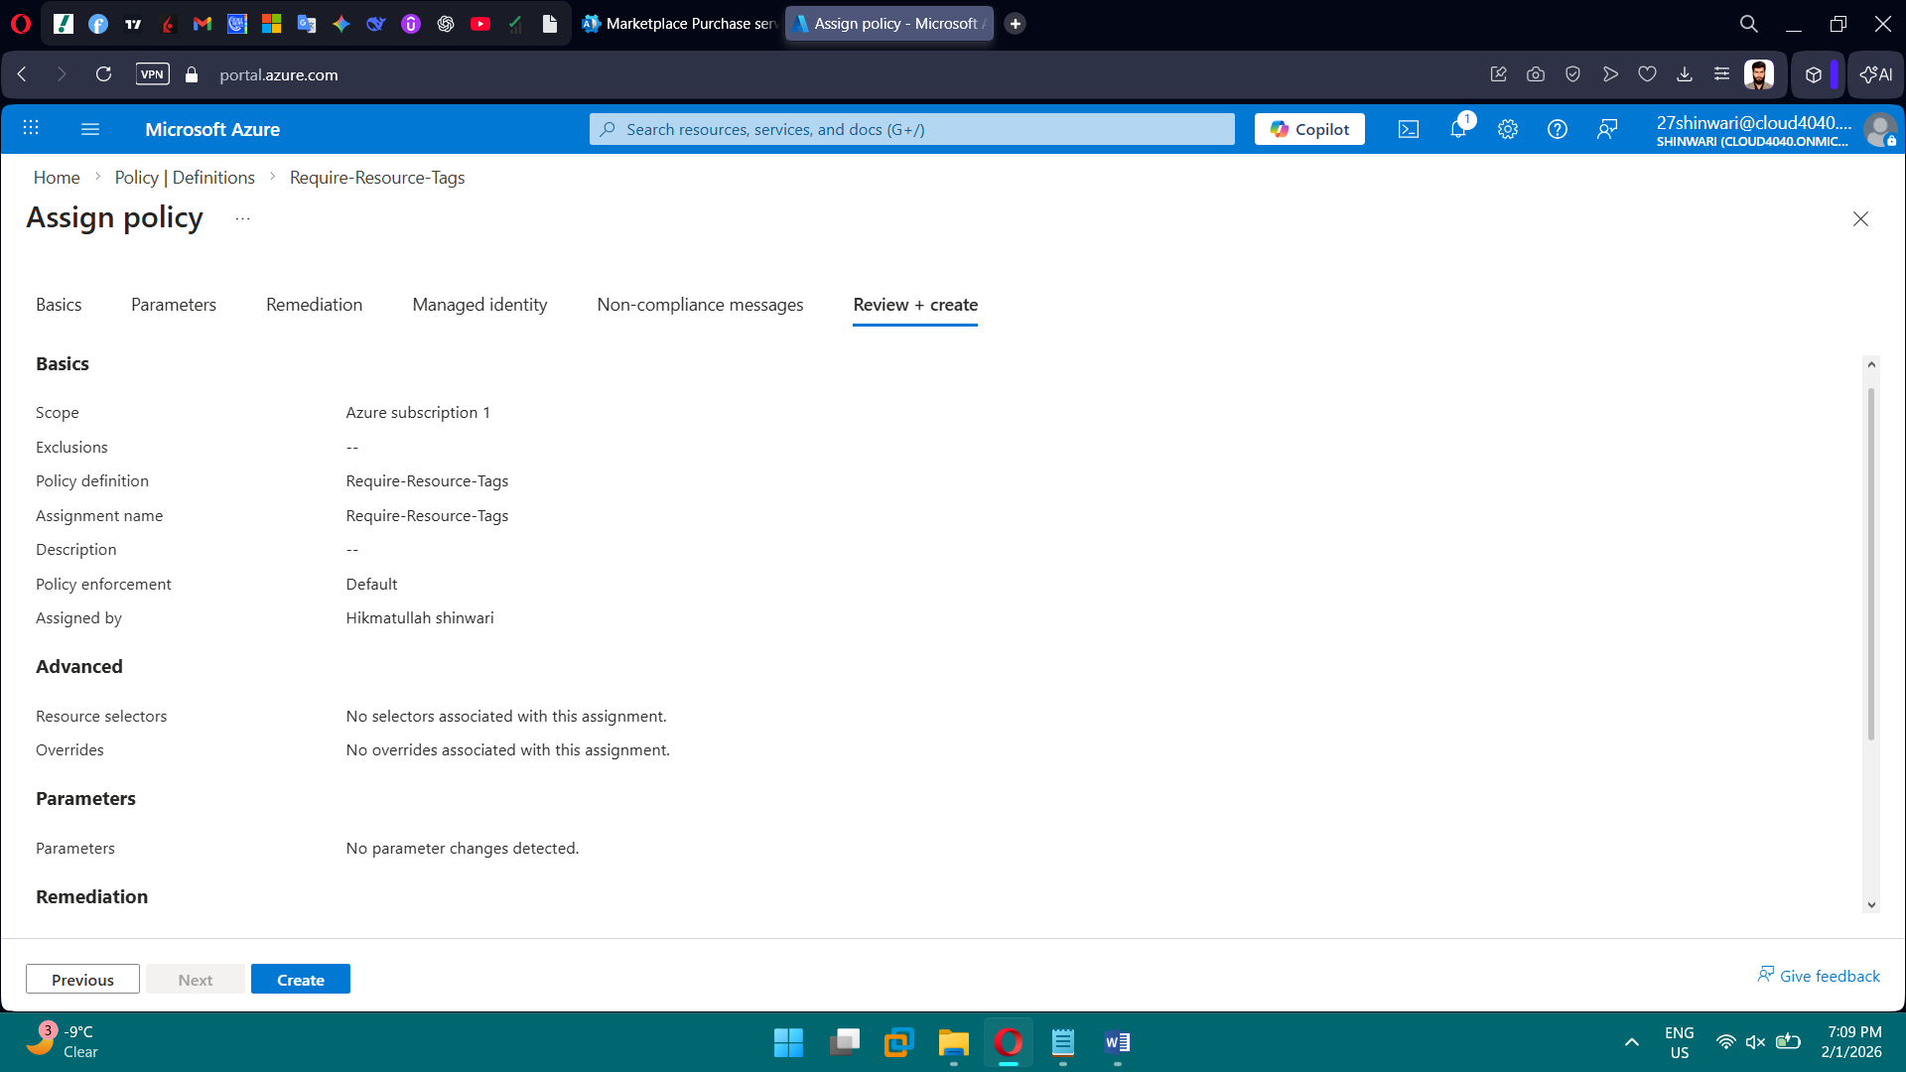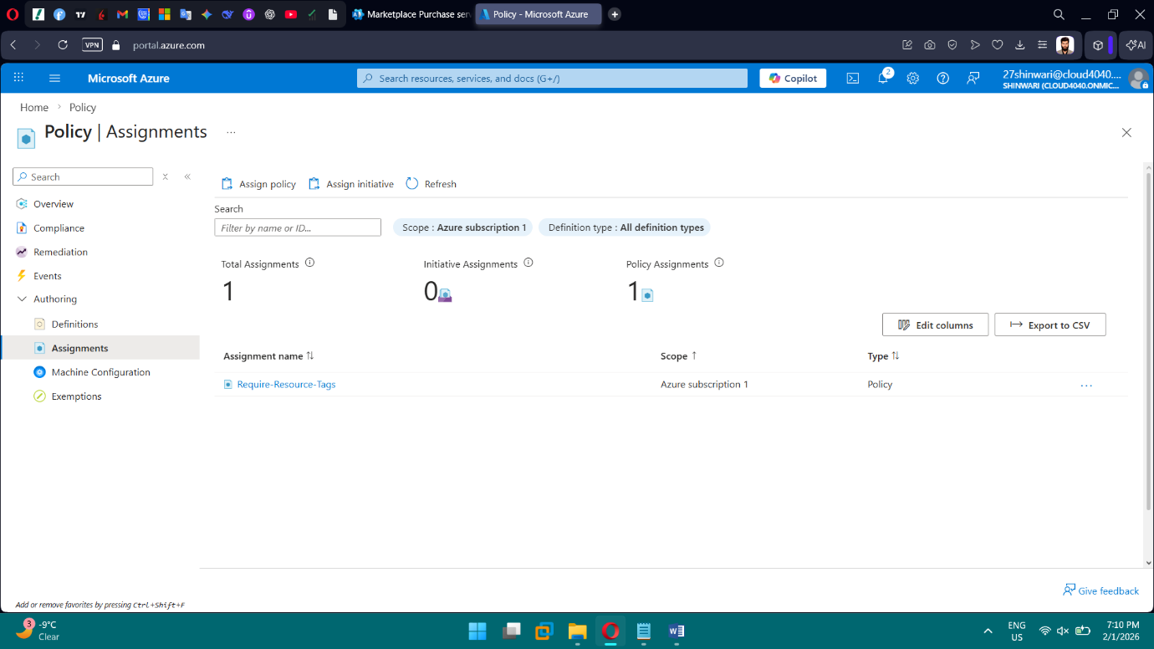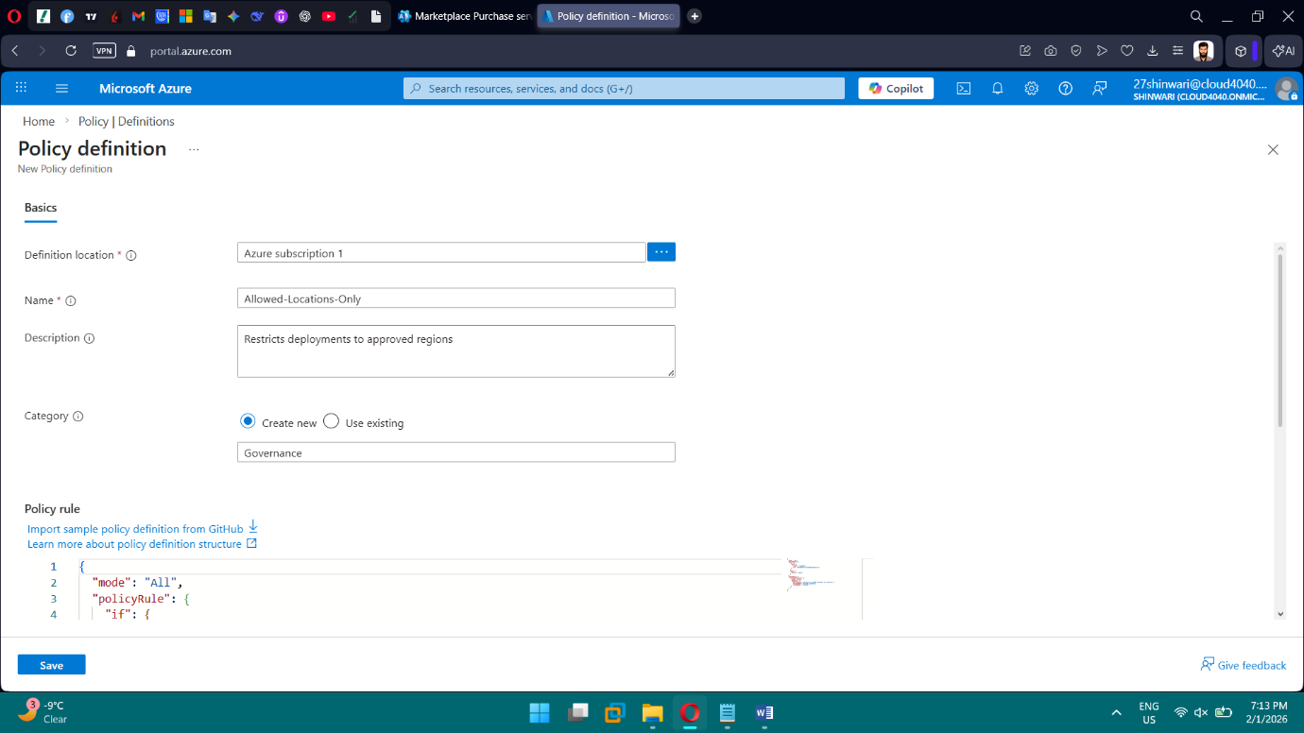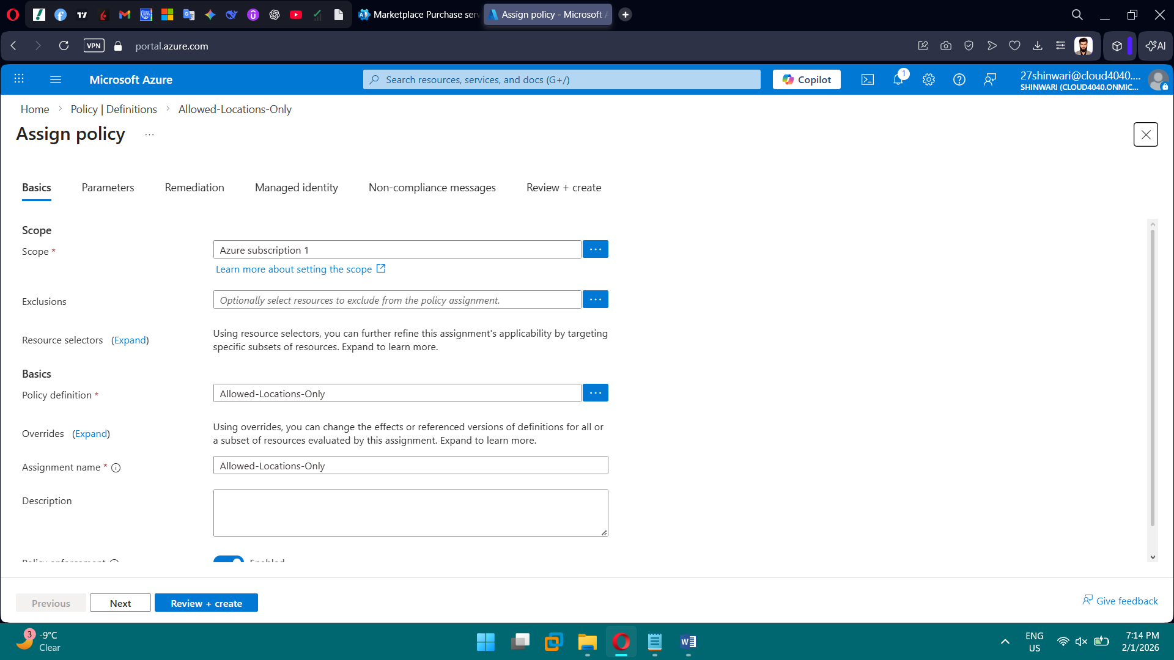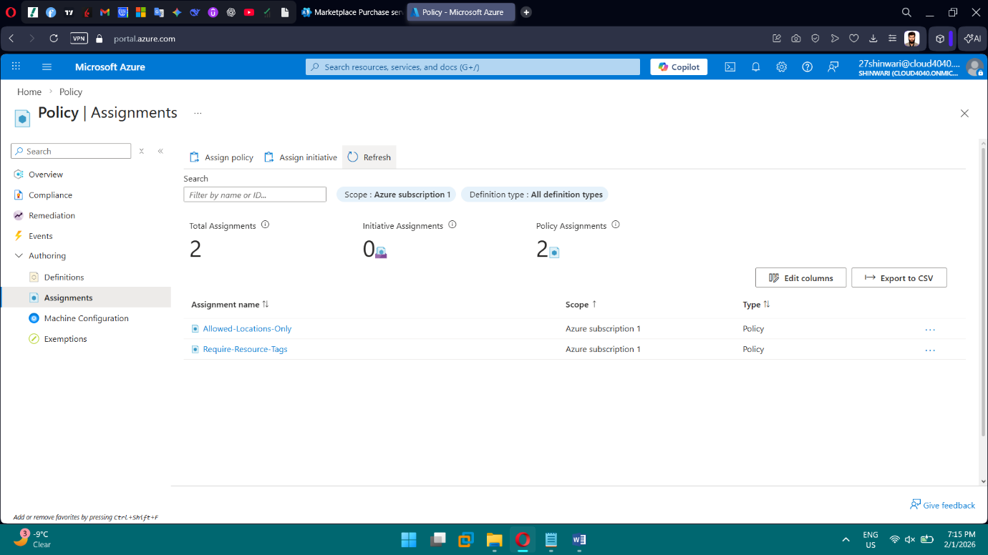

**Phase 4: Resource Organization & Cost Management**

**Tasks**

* Organize resources using standardized Resource Groups
* Configure monthly cost budgets
* Set budget alerts
* Identify cost optimization opportunities

**Brief Explanation:** Created standardized Resource Groups to organize lab resources. Deployed sample resources with consistent naming conventions and applied mandatory tags. Configured monthly budgets and set alert thresholds at 50%, 80%, and 100% of spend to monitor costs. Reviewed cost analysis and documented potential optimization opportunities. Ensured proactive cost governance and resource lifecycle management.

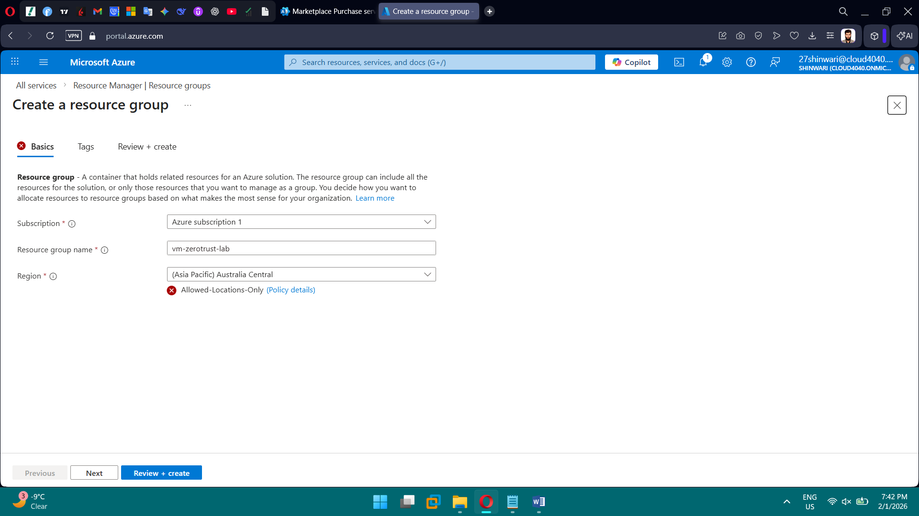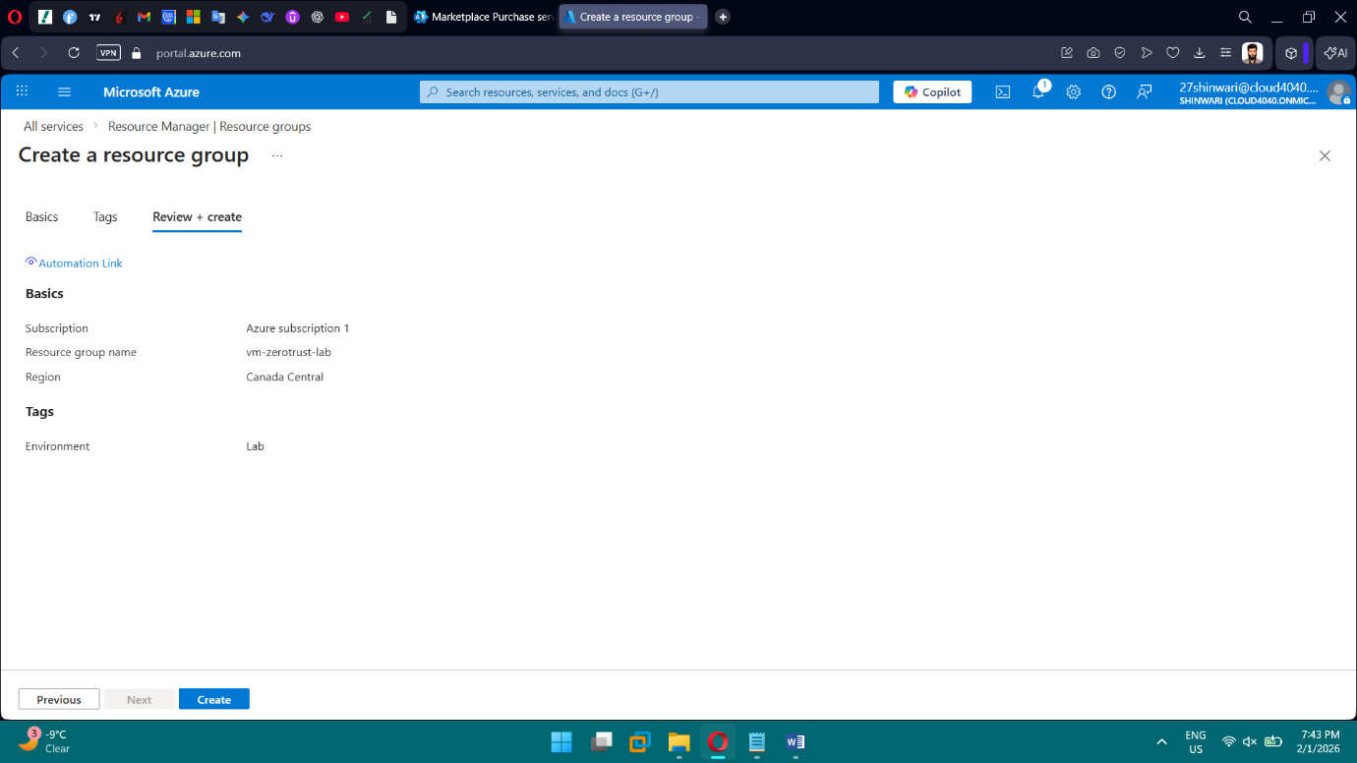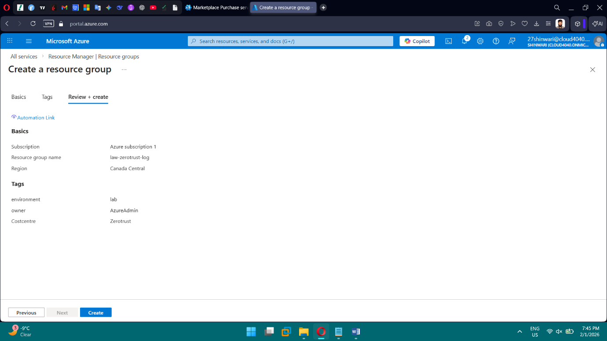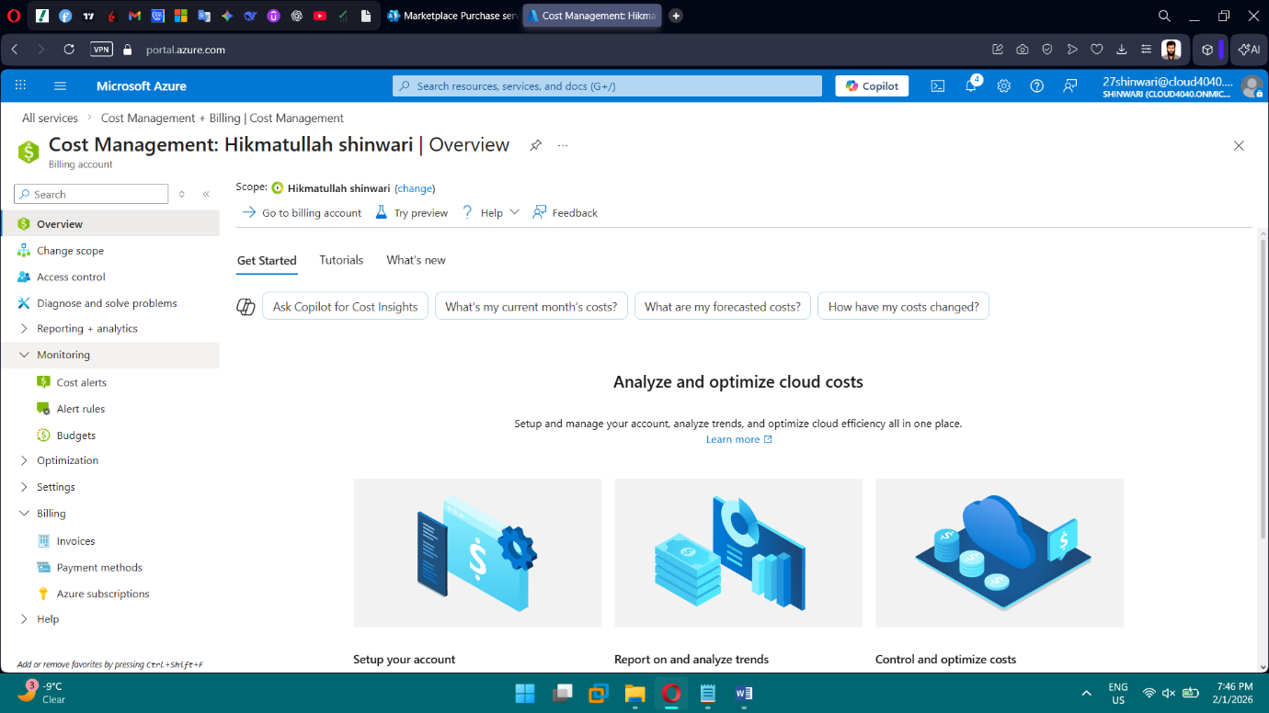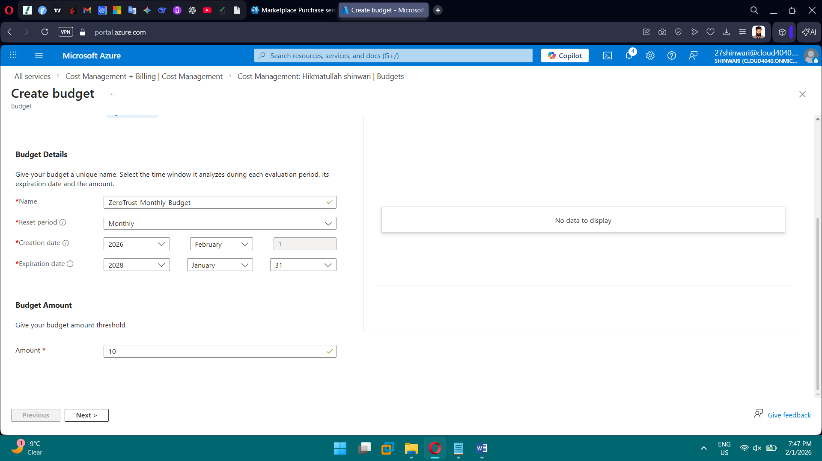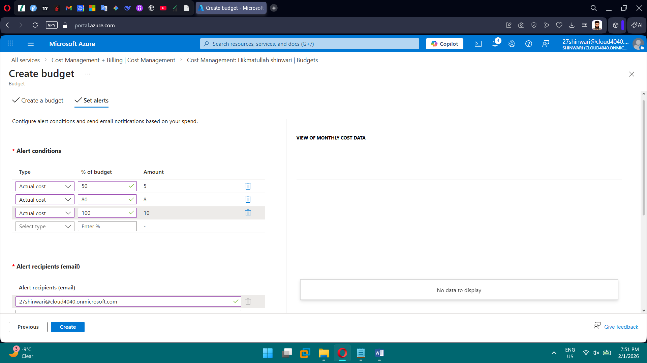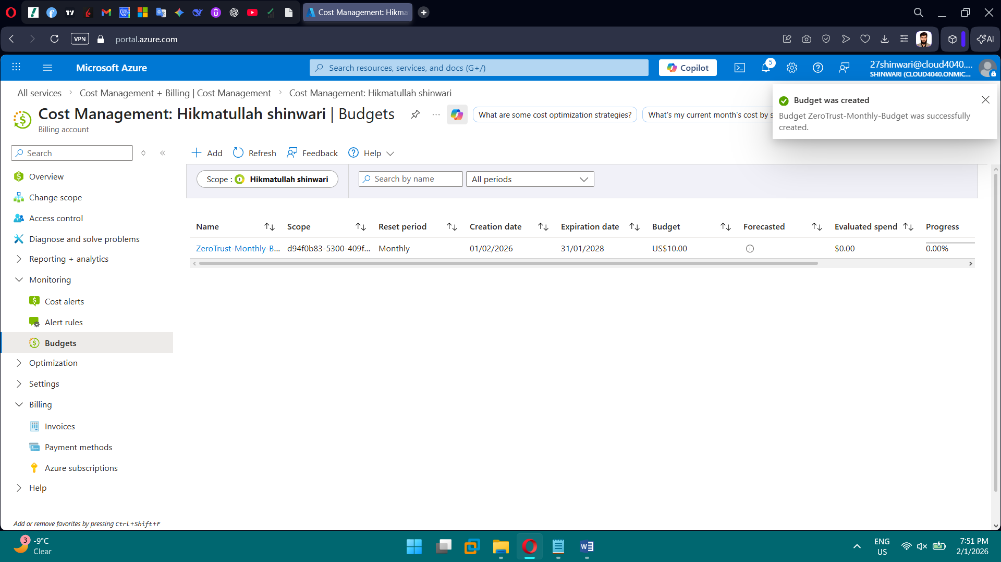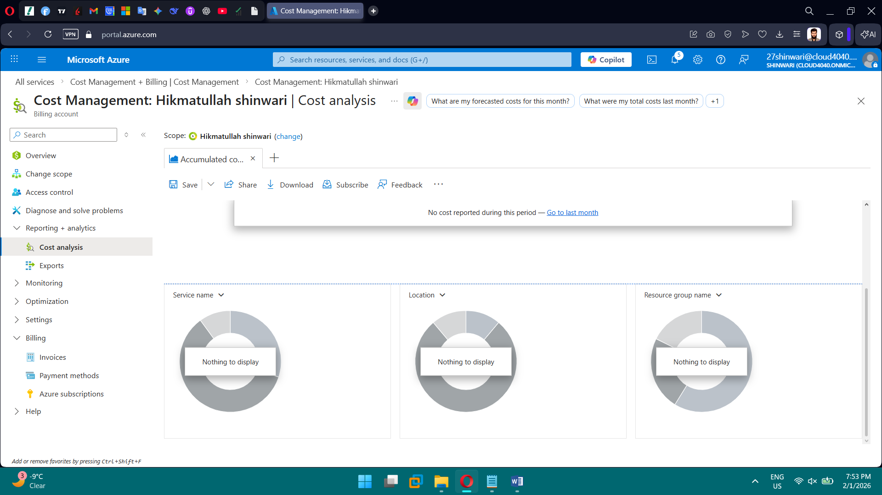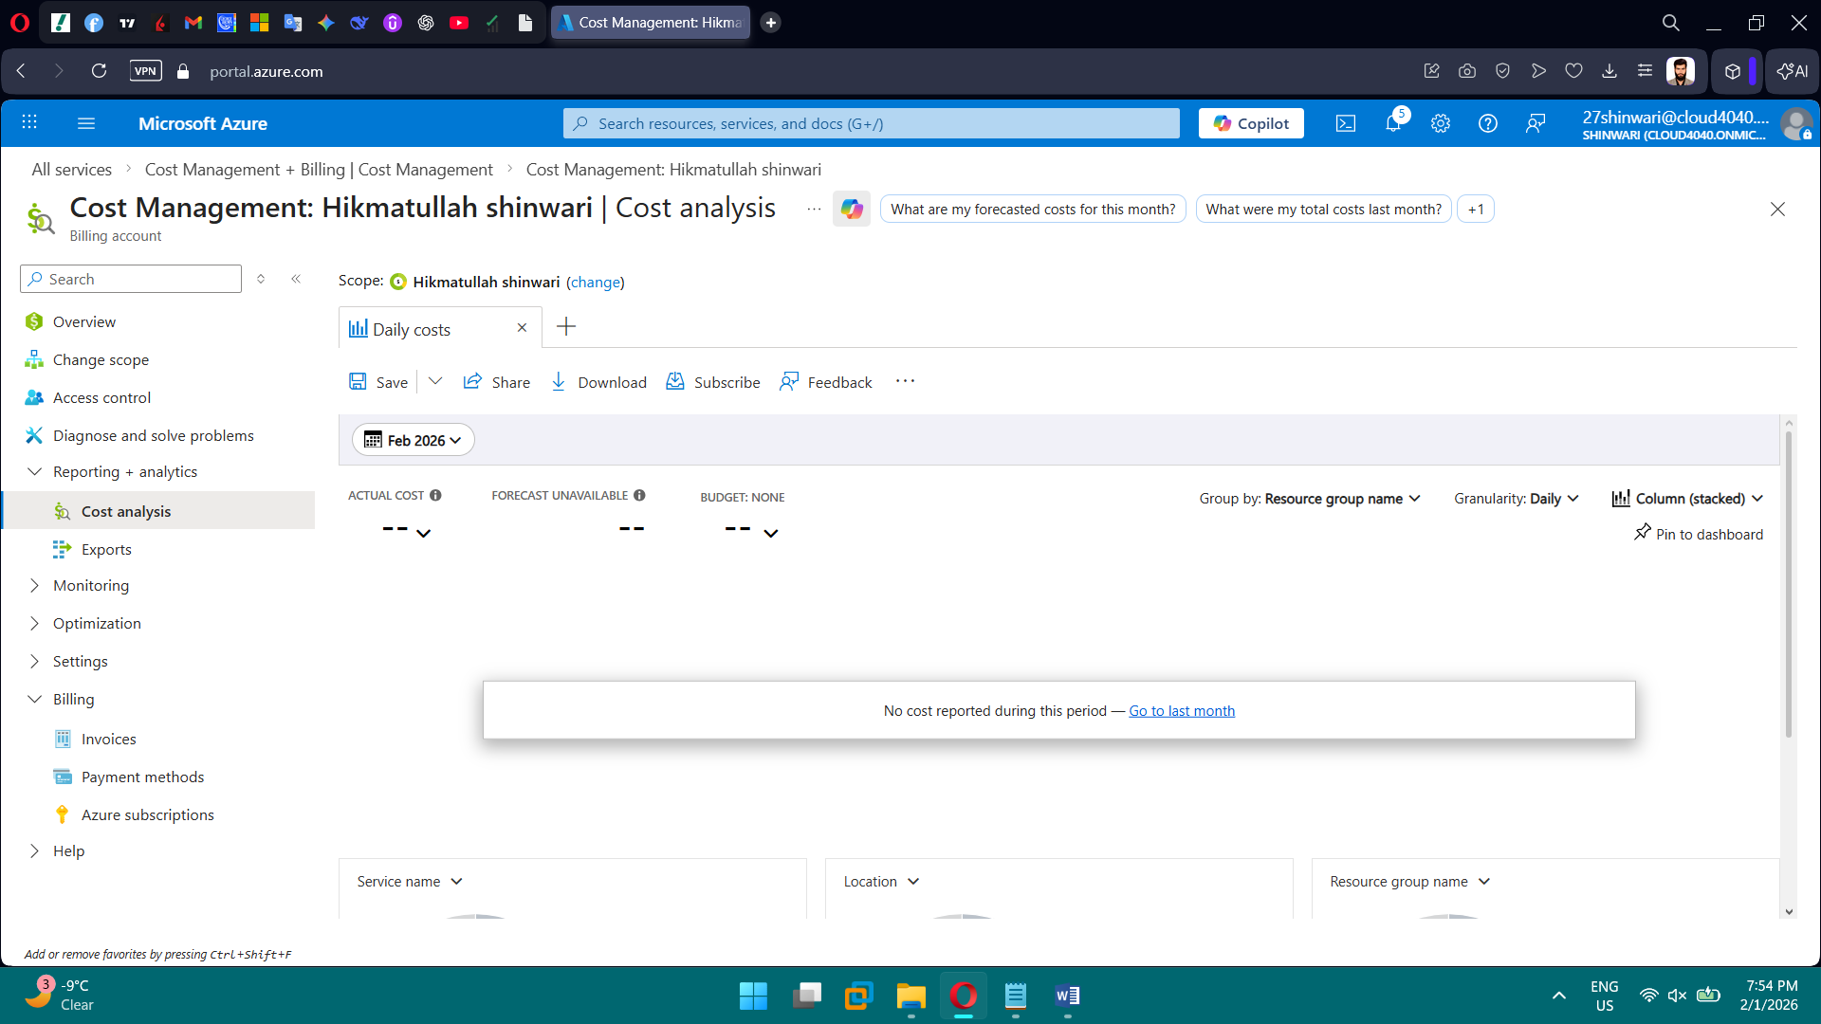

**Phase 5: Monitoring, Logging & Alerts**

**Tasks**

* Enable and review Azure Activity Logs
* Review Azure Entra ID sign-in logs
* Create alerts for:
  + Failed sign-in attempts
  + Role assignment changes
* Configure email-based notifications

**Brief Explanation:** Enabled Azure Activity Logs to track all management operations at the subscription and resource group level. Reviewed Entra ID sign-in logs to monitor user authentication activity, detecting potential unauthorized access. Created alerts for critical events like role assignment changes and, where possible, failed sign-ins, with email notifications to administrators. Tested alert delivery to ensure operational monitoring and security awareness. Documented all logs, alerts, and test results for audit and compliance purposes.

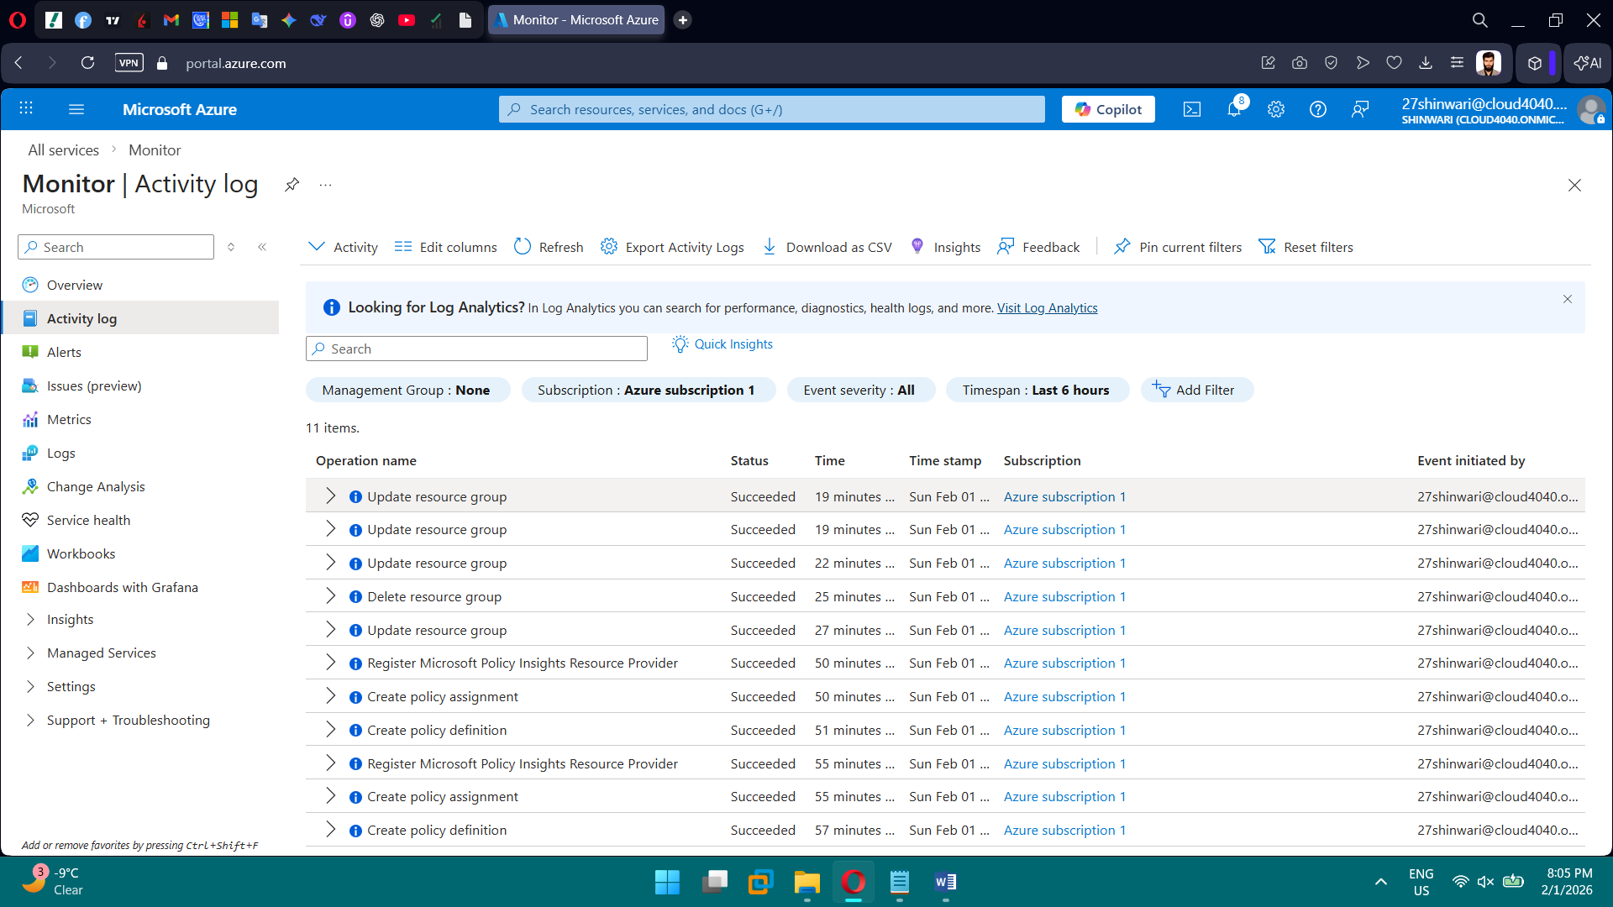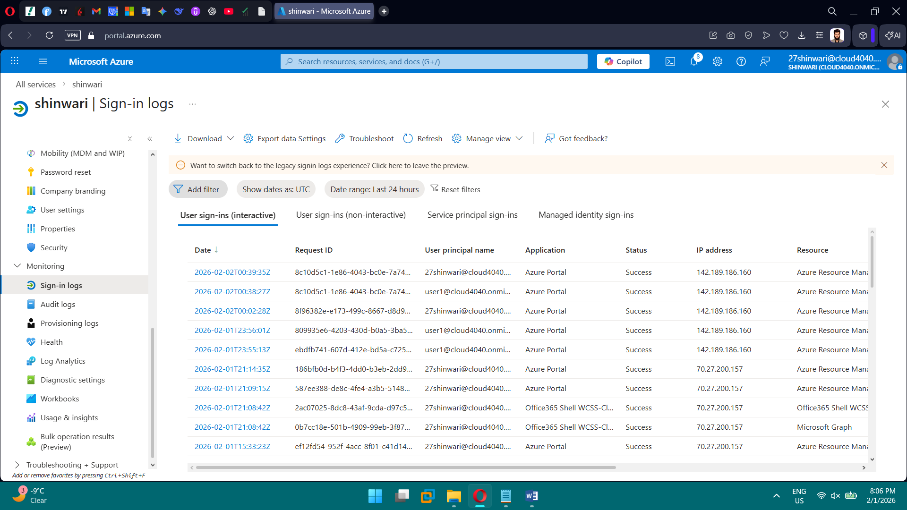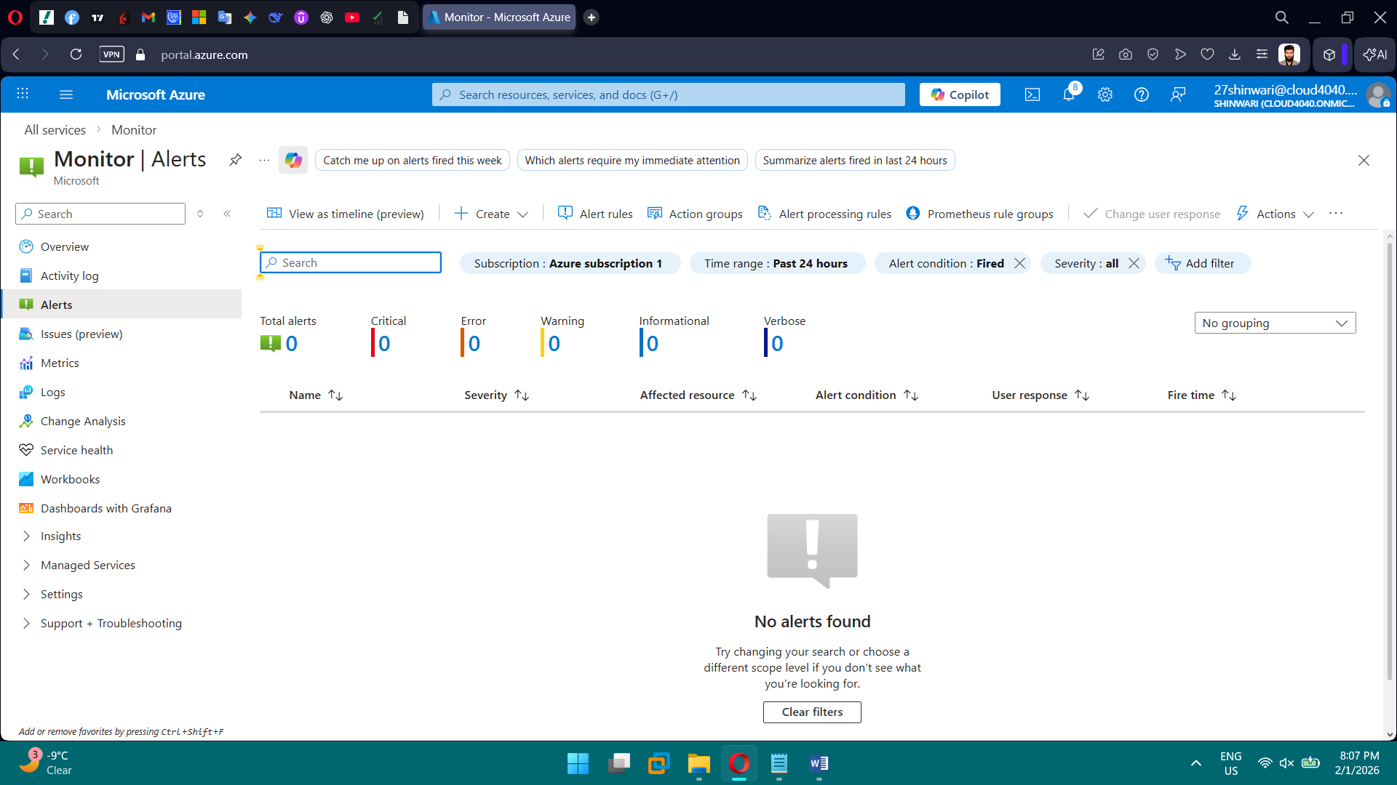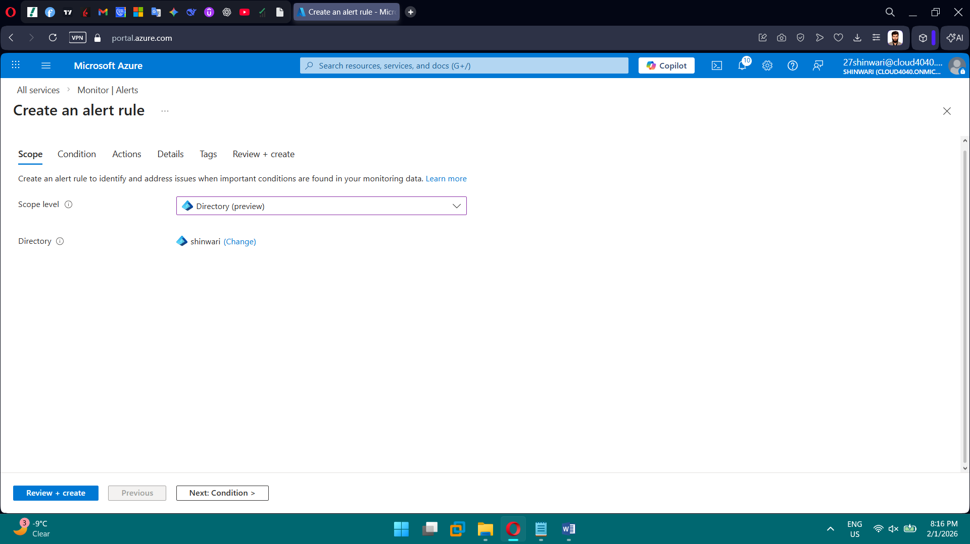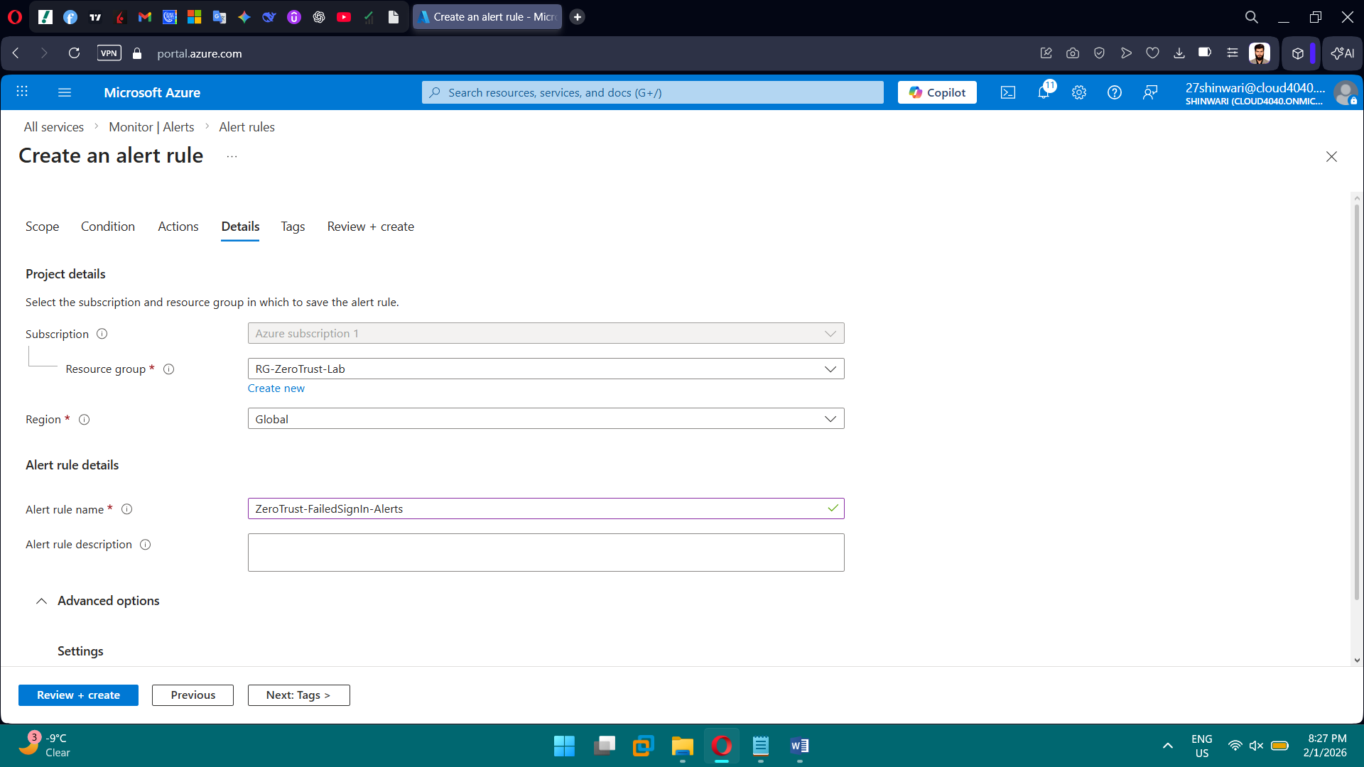

**Phase 6: Incident Response & Operational Readiness**

**Tasks**

* Design incident response procedures for:
  + Account compromise
  + Unauthorized access attempts
* Document step-by-step response actions
* Create an administrator operational checklist

**Brief Explanation:** We designed and documented incident response procedures for security events such as account compromise and unauthorized access attempts. We defined the correct response order, including identifying suspicious activity using Entra ID sign-in logs, resetting credentials, enforcing MFA, and safely isolating affected accounts. Administrative actions were validated using both Azure Portal and PowerShell to reflect real-world SOC operations. Finally, we documented remediation, reporting steps, and operational best practices to ensure secure recovery and ongoing monitoring.

